IONIZATION OF LARGE AREAS OF AIR
N.V. Ardelyan*, V.L. Bychkov, K.V. Kosmachevskii*, and D.S. Maksimov
Moscow Radiotechnical Institute RAS, Warsawskoe Shosses, 132, 117519 Moscow, Russia,
bychvl@gmauil.com
*Faculty of CS and Cybernetics, M.V. Lomonosov MSU, Leninskye gory, 119991 Moscow,
Russia, cmc@cs.msu.ru
Questions of ionization of large air regions during geophysical processes accompanied by rise of local values of Earth electric field and background ionization at distance of several meters is of great interest with connection of investigations of fire origination and inflammation of different flammable liquid storages. Typical values of volumetric processes in this case exceed velocities of diffuse and thermal conductivity processes during a long time, during which processes of origination and elimination of charged particles take place at the same time the local gas heating during relaxation processes takes place. In this case the ionization processes have a special type. And the temperature rise can lead to inflammation of flammable substances. In the work we have considered a mathematical 1D model of multicomponent air plasma with accounting of electron and gas temperatures. In all the calculations with external electric field below 35 kV/cm one can single out three stages: a prebreakdown (linear) ionization, intermediate (non-linear) stage with a slow ionization and with electronegative (ion-ion) plasma; and the stage of, so called, “breakdown-discharge” (non-linear) with strong and quick heating of the gas and transition to the electron-ion plasma. An ionization level of plasma rises after the discharge with increase of the electric field. The prebreakdown ionization takes place considerably quicker the ionization at the intermediate stage. The duration of all stages decreases with rise of the electric field. At the field of 35 kV/cm the discharge time is comparable with the duration of the prebreakdown ionization stage, the second (intermediate) stage is absent, the prebreakdown linear stage transits to the “breakdown-discharge” with thermal heating. (Initial conditions N_{g}=2.55 10¹⁹ cm⁻³, concentrations of components – 1 cm⁻³, Has temperature – 320 К, power of the electron-pairs source – 3660 eV/(cm³s).
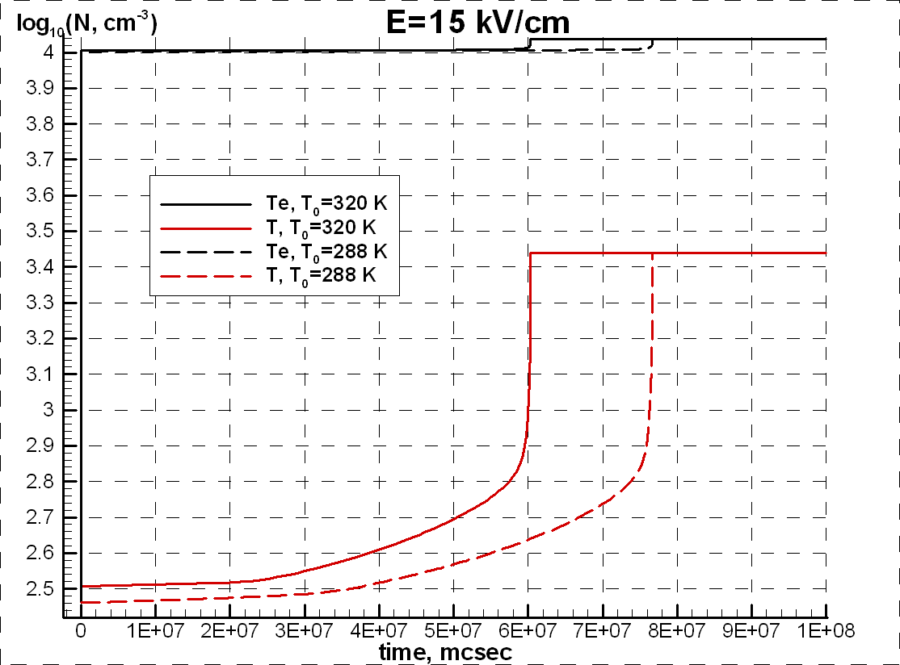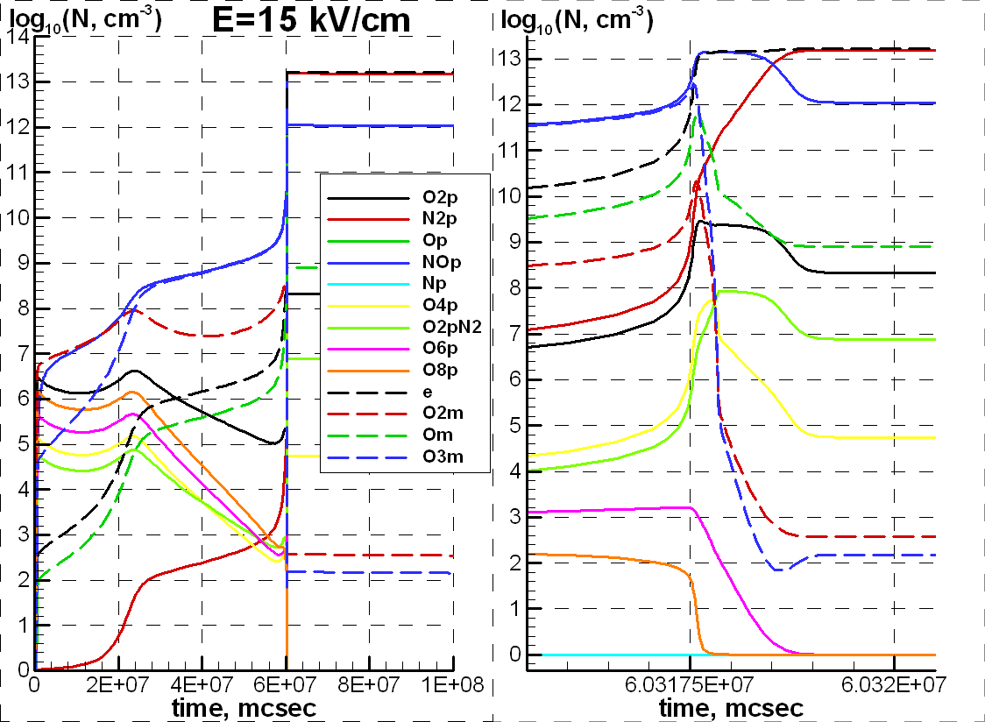
The work was partially supported by the grant of RFBR 12-07-00654.

