GENERATION OF A LASER-PLASMA ION FLOW of atmosfheric pressure IN A MICROWAVE field
A. Medvedev, G. Grachev
Institute of Laser Physics SB RAS, Novosibirsk, Russia, medvedev@laser.nsc.ru
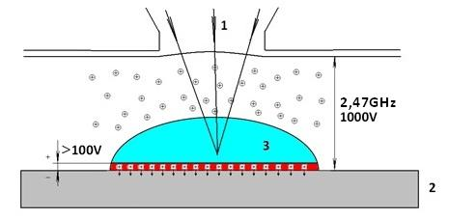
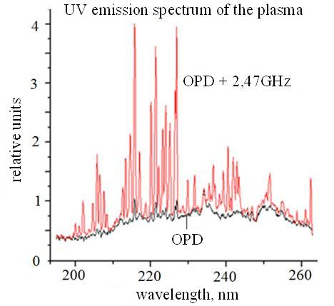
Laser plasma modification of metal surfaces increases the hardness, strength, wear qualities, corrosion resistance, and other exploitation characteristics of laser-plasma treated workpieces [1]. To increase the capabilities of the laser plasma method, it was proposed to inject microwave energy into laser plasma for the purpose of increasing the efficiency and controllability of the processes of technological treatment of materials [2]. The physical mechanisms of the experiment are illustrated in Fig. 1. Focused pulse-periodic (PP) radiation 1 with a frequency (f) of 30-70 kHz and a pulse duration of ~1 μs creates, at exposed target 2, an optical pulsating discharge (OPD) 3. Microwave current passage through plasma causes voltage drop on the charged near-boundary plasma-metal layer. The average laser radiation power is ~1 kW. The OPD burns in the PP microwave field (2, 47 GHz). The repetition frequency of microwave pulses is equal to f, the duration is ~1-2 μs, and the average power, 50-100 W. Measurements of the laser plasma spectral composition in the range of 180-1100 nm revealed a considerable reaction of the range of 200-260 nm to the presence of microwave current in the plasma. Considerable amplification of individual UV radiation spectrum lines (Fig. 2) indicates the appearance of high-energy ions with an energy of about 5 eV, which are not present in laser plasma without a microwave field. The observed enrichment of the spectrum short-wave part is caused by the effect of the microwave field on the plasma–metal system: fast alternating current through the plasma makes electrons move to the metal and creates a constant plasma–metal potential difference, presumably up to 100 and more V. This causes a considerable increase in the energy of ions going to the surface. The charged layer of the plasma–metal boundary is determined by the power injected into the microwave plasma. On the basis of this effect, a method of controlling the occurrence depth of implanted ions and the treated surface quality is proposed.
References
- S.N. Bagaev, G.N. Grachev, A.L. Smirnov, M.N. Khomyakov, L.D. Makagon, A.O. Tokarev, P.Yu. Smirnov. The application of the laser-plasma modification of a surface of metals to improve the tribological characteristics of a combustion engines. // Metal (technology, equipment, tools). 2014, №1 (62), P.14-23.
- A.E. Medvedev, G.N. Grachev, A.M. Barnyakov, Yu.D. Chernousov. The technological head for a surface treatment of the laser plasma with cash on a microwave field. The patent application №2014131181 from 28.07.2014.

