MULTI-CHANNEL SCINTILLATION DIAGNOSTICS OF VARIOUS RADIATIONS IN PREPULSE STAGE FOR EXTENDED ATMOSPHERIC DISCHARGE IN THE ERG INSTALLATION
A.A. Rodionov^{1,2}, A.V. Oginov¹, K.V. Shpakov¹
¹Lebedev Physical Institute of RAS, Moscow, RF, ra1231@gmail.com
²Moscow Institute of Physics and Technology (State University), Moscow, RF
Studies of the atmospheric discharge at the ERG installation (LPI RAS) [1-2] have shown the need for the development of scintillation diagnostics. It is required to study low-background registration of short impulses of x-ray and gamma radiation with photon energies from tens of keV to a several MeV [1], and fast neutrons too [2]. It is important to provide the best time and amplitude resolution on the available types of photomultipliers and available hardware components.
The paper presents the features of created "fast" scintillation detectors of radiation, based on the native PMT (the time resolution is ~5 ns), in assembly with use of various types of organic and inorganic scintillators. The special high-voltage power supply circuit, using the Zener voltage clamp circuit at the last stages of PMT amplification, was developed for providing demanded characteristics. Power dividers were optimized by techniques [3,4] to eliminate the instability of the PMT caused by a high time averaged load, and the linearity violation in pulse response. While detector carcasses were designed, particular attention was paid to shielding from strong electromagnetic interference, which occurs at the time of discharge. That’s why the elements of the carcasses were made of permalloy alloy 79HM.
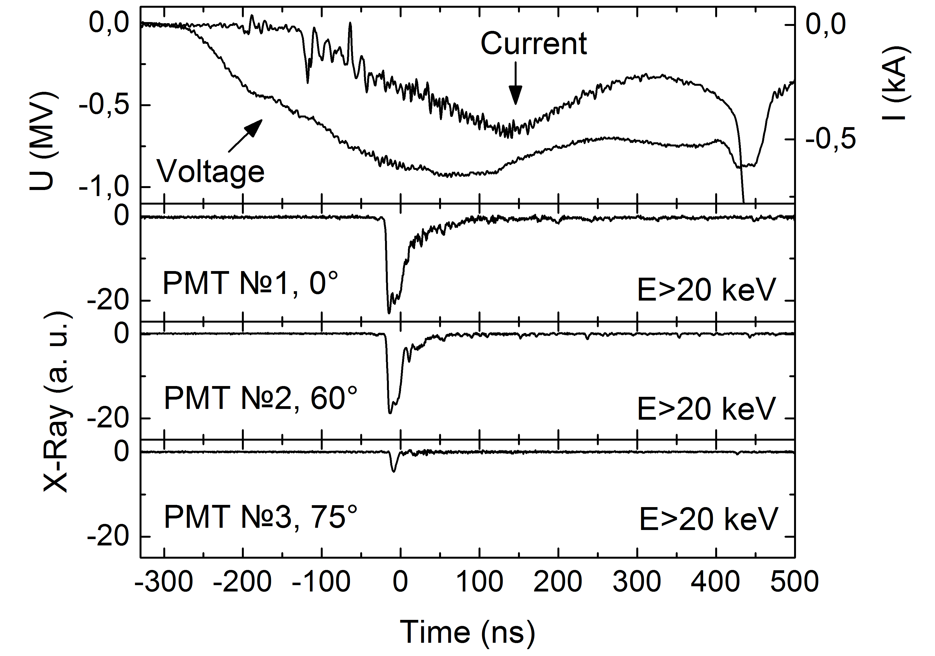
The results of experimental studies of the anisotropy of short pulses of soft and hard X-ray, gamma and neutron radiation, arising during the course of atmospheric discharge in ERG (LNAP NPAD LPI) are given.
Statistical data, collected during a consecutive series of experiments, allows to claim about the presence of radiation, its anisotropic character and also shows the relationship of the observed phenomena with characteristic values of current and voltage of prepulse phase of atmospheric discharge.
This work was supported by RFBR (grant 14-08-31397 mol_a, 13-08-01379) and grant Educational and Scientific LPI Complex (UNK).
References
- A. V. Agafonov, A. V. Oginov, and K. V. Shpakov, Prebreakdown Phase in Atmospheric Discharges, Physics of Particles and Nuclei Letters, 2012, Vol. 9, No. 4–5, pp. 380–383.
- A. V. Agafonov, A. V. Bagulya, O. D. Dalkarov et al. Observation of Neutron Bursts Produced by Laboratory High-Voltage Atmospheric Discharge, Phys. Rev. Lett., 111, 115003 (2013).
- Basiladze S.G., Ivanov V.I., Preprint, 13-9172, Dubna, 1975.
- Baldakin B.O., Ronzhin A.P., Cisek Z., Preprint, PI3-7859, Dubna 1974.

