numerical simulation of the two-dimensional structure of penning discharge in molecular hydrogen at pressures 0.1 – 5 torr
D.A. Storozhev, ¹S.T. Surzhikov, and ²S.E. Kuratov
Moscow institute of physics and technology (state university), Moscow, Russia,
dmitry.stor@gmail.com
¹Institute for Problems in Mechanics RAS, Moscow, Russia, surg@ipmnet.ru
²Center for Basic and Applied Research, All-Russian Scientific Research Institute of
Automatics, Moscow, Russia
A stationary electrodynamic structure of penning discharge in molecular hydrogen is investigated (spatial distributions of the electron and ion concentrations as well as the electric field in the area of existing the discharge are considered). Schematic of the problem is presented in Fig. 1. (the dimensions are presented in Fig.2-4). The following initial data are used: emf Е=500 V, ohmic resistance of the external electrical network 3 кΩ. With the use of numerical simulation the structure of the glow discharge with decreasing pressure from 5 Torr to 0.1 Torr (Fig.2 and 3) and with axial magnetic field (transition to the penning discharge, Fig. 4) is investigated. Spatial distributions of the electron concentrations are shown in Fig. 2-4.
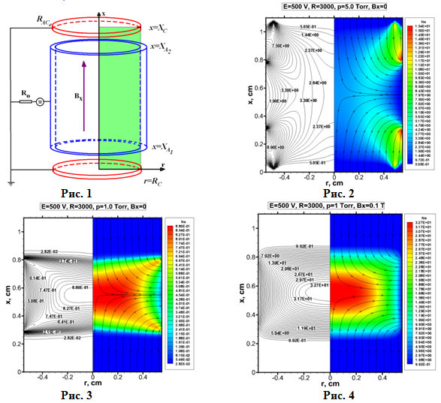
Two-fluid and two-temperature drift-diffusion model described in details in [1] is used. The analysis of plasma-chemical model that underlies the ionization kinetics was performed.
References
- Surzhikov S.T. Computational Physics of Electric Discharges in Gas Flows. 2013, Walter de Gruyter GmbH, Berlin/Boston

