formation of collimated Fast electron beam under interaction of 100-ns UV laser pulses with targets
V.D. Zvorykin
P.N. Lebedev Physical Institute of Russian Academy of Sciences, Moscow, Russia, zvorykin@sci.lebedev.ru
Fast superthermal electrons with energies of a few keV, which considerably exceeds average electron energy in laser plasma, are generated due to a development of parametric instabilities in plasma corona [1]. Such process constrains maximal intensity of nanosecond pulses intended for a direct compression of thermonuclear targets in the ICF by values 10¹⁴−10¹⁵ W/сm² [2]. Opposite case is a fast-ignition ICF sheme where collimated electron beam accelerated up to 1-MeV energy must deliver for ~ 20 ps into a preliminary compressed target ~ 20 kJ of energy, that requires very high intensity ~10¹⁹ W/сm² and peak power of a short laser pulse up to several petawatts.
In our experiments a collimated beam of MeV-energy electrons was produced in the forward direction by laser radiation of rather moderate intensity of 10¹²−10¹³ W/сm².
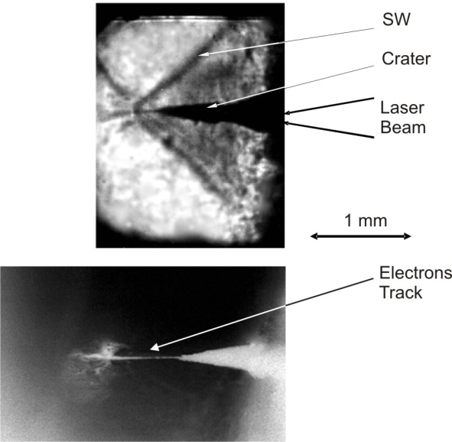 | When narrow-bandwidth UV radiation of KrF laser (λ = 248 nm, Δλ ~ 10⁻³ nm) with a pulse energy up to 100 J and duration of 100 ns was focused in a spot of ~ 100-m diameter onto a target of polymethyl methacrylate (plexiglas), conditions for a two-dimensional hydrodynamic flow arose: an ablation front moved inside the target with a supersound velocity of 4−5 km/s (sound velocity in a plexiglas is 2.7 km/s) and it produced cone-like Mach shock wave [3]. Due to a radial squeezing out of the matter a deep (~ 1 mm) conical crater grew in the target (see an upper picture).
Interesting and not yet described feature of such interaction regime is a very narrow (of 40-μm diameter) and extended channel going from the crater tip along ~ 1-mm length (see a bottom picture). An origin of this channel cannot be explained by a self-focusing of UV radiation in a plexiglas, as its penetration length is of a few microns. Most likely, the channel represents a track produced by a collimated electron beam, which was formed due to an effective development of parametric plasma instabilities along an extended nonlinear interaction length of narrow-bandwidth laser radiation with erosion plasma in the deep crater. A typical behavior of electron beam break-up is also observed in the picture. Electron energy as high as 0.4 MeV is estimated based on the found range of electrons, being many orders of magnitude higher than electron temperature ~100 eV in plasma corona [3].
References
- V.P. Silin “Parametric interaction of high-power radiation with plasma”. М.: Nauka, 1973 (in Russian).
- S. Atzeni, Plasma Phys. Control. Fusion, 51, 124029 (2009).
- V.D. Zvorykin, V.G. Bakaev, I.G. Lebo, G.V. Sychugov, Laser and Particle Beams, 22, 51 (2004).

