FORMATION OF PLASMOIDS WHEN EXPOSED TO CAPILLARY DISCHARGE TO METALS *)
DOI: 10.34854/ICPAF.2023.50.2023.1.1.212
Bychkov V.L., Baidak V.A., Vaulin D.N., Sorokov D.E., Chernikov V.A.
Lomonosov Moscow State University, Moscow, Russia bychvl@gmail.com
The interest in the effect of capillary discharge plasma in air to the surface of various metallic and dielectric materials is of a practical nature. It is connected with the study of the creation of new consumer properties of surfaces and particles formed on these surfaces under the action of capillary discharge plasma. Its schematic diagram is shown in Fig. 1.
Usually, the capillary plasma torch in our experiments had the following characteristics: the pulse duration was 7-14 ms, the pulse energy varied in the range of 300-1500 J, the voltage at the discharge interval was 300 V, the pulse current values were 50-100 A. The diameter of the plasma torch channel is from 1.5-2 mm. The jet length was 11.0-14.0 cm. The temperature of the plasmoid can be 6000-7000 K.
When a capillary discharge plasmoid was exposed to solder samples, in addition to solder drops, long-lived luminous formations up to 1.5 cm in size and a characteristic lifetime of more than 6-7 seconds appeared. They exploded and left traces of the explosion on the paper. This effect opens up a new way to create additives for fuels that are formed during the operation of the plasma torch.
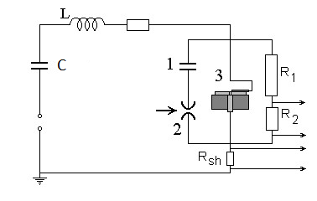
When the discharge plasma was exposed to graphite samples, structures such as graphene and nanotubes were formed on its surface. These experiments, which are preliminary in nature, show that the creation of nanocomponents can occur under conditions of capillary discharge plasma in air.
Fig. 1. Diagram of the capillary plasma torch.
1 – initiating capacitance,
2 – switch,
3 – capillary, R1, R2 – voltage divider resistances, Rsh – shunt resistance for determining discharge current, C - capacitor bank

*) abstracts of this report in Russian

