THE EFFECT OF CORONA DISCHARGE ON THE SURFACE OF FUNGI INFECTED WINTER WHEAT GRAIN *)
DOI: 10.34854/ICPAF.2023.50.2023.1.1.211
Bychkov V.L., Vaulin D.N., Goryachkin P.A., Chernikov V.A.
Lomonosov Moscow State University, Moscow, Russia, bychvl@gmail.com
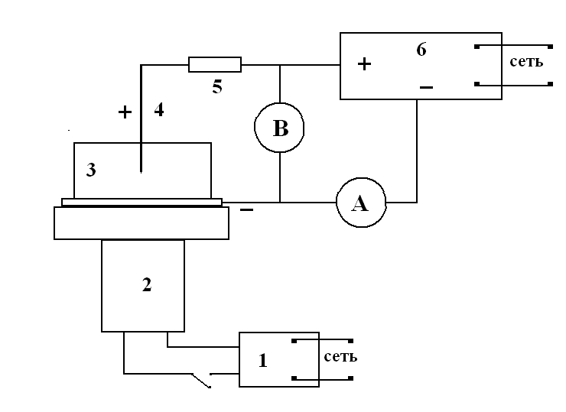
The interest in the effect of corona discharge plasma in air on the surface of various biological objects is of a practical nature. To combat fungal diseases of wheat, seed etching with chemicals is usually used. Currently, new technologies related to the use of low-temperature atmospheric pressure plasma are being intensively developed. This allows to use such plasma for the treatment of heat-sensitive materials, including biological tissues, plant seeds and plants themselves. In this paper, the effect of corona discharges on the infection of seeds of soft winter wheat of the Chef variety with fungal diseases is investigated.
Figure 1 shows a schematic diagram. It consists of a cuvette filled with the substance under study and an electrical circuit. The upper electrode or a set of electrodes with a diameter of 0.9 mm (with a tip radius of 0.2 mm) or 2 mm (with a tip radius of 0.4 mm) was located at a height of 8 mm above the surface of the test substance. The distance between the electrodes in the upper multielectrode composition (4) was 11 mm. The electrodes were under positive or negative voltage. The cuvette (3) was dielectric (with a metal electrode on its bottom) or metallic, cylindrical, 90 mm in diameter, Fig. 1. 18 mm high. For a more uniform treatment of the substance in the cuvette (3), an electric motor (2) was used. The exposure time in winter wheat seed treatment experiments was up to 2-3 hours.
Studies have been conducted on the effects of positive and negative corona discharge on soft winter wheat seeds infected with hard smut, alternariasis and helminthosporiosis. The results showed that the treatment of seeds with a positive crown had a stronger disinfecting effect compared to a negative crown. At the same time, the optimal exposure time (in germination) for a negative crown was the range of 60-90 minutes. A positive crown led to a depression in the germination of wheat seeds to 5-7%, reducing its level below the requirements of the standard. With the revealed suppression of alternariasis and helminthosporiosis by plasma, there is no need to use chemical seed protectants. To the least extent, the effect of corona discharges had on the infection of seeds with hard smut.
The data obtained in the study indicate that there is a need to continue research in this direction in order to determine the optimal duration of exposure to infected grain and the corresponding discharge capacities.

*) abstracts of this report in Russian

