Initiation of a Plasma Discharge from the Surface of a Quartz Plate in the Transmission of a Microwave Pulse gyrotron (75 GHz, 400 kW, 8 ms) *)
DOI: 10.34854/ICPAF.2023.50.2023.1.1.208
Zakletskii Z.A., Malakhov D.V., Gusein-Zade N.G., Voronova E.V., Badyanova L.V., Stepakhin V.D.
Prokhorov General Physics Intstitute of the Russian Academy of Sciences, fiveziggen@gmail.com
Problems associated with the thresholds of plasma formation during the radiation of complex metal-dielectric targets by microwaves, both in high vacuum and in various gases, have been caused for a long time [1].
This paper presents a study of the initiation and development of a microwave discharge that occurs during the passage of a millisecond microwave pulse of a gyrotron on the surface of a quartz substrate with metal microparticles embedded in it. The results of microwave measurements of the absorption of microwave radiation in this process, estimates of the velocity of the discharge front along the surface of the plate, and the dependence of the substrate temperature on the duration of the microwave pulse are presented. The results of spectral analysis are also presented - rotational and vibrational temperatures of molecules.
Visualization of the initiation and development of a microwave discharge that occurs during the passage of a millisecond microwave pulse of the gyrotron is carried out using a high-speed Phanton VEO camera (speed 7400 frames per second at a resolution of 1280 x 800). The upper part of Figure 1 shows a surface discharge maintained by a gyrotron microwave pulse with a duration of 8 ms, the lower part shows the first frame obtained after the end of the microwave pulse.
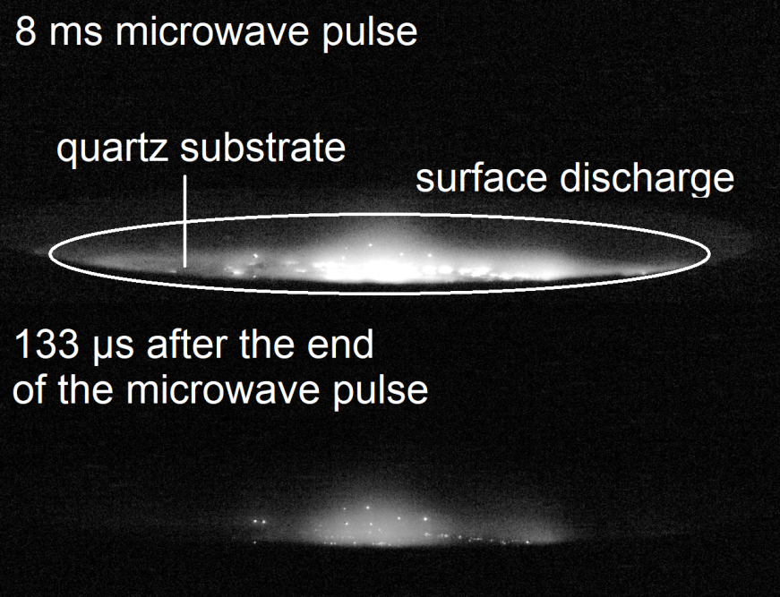
Fig.1 - A characteristic side view of the surface of the quartz substrate from which the discharge develops
References
- G.M. Batanov et al 1996 J. Phys. D: Appl. Phys. 29 1641

*) abstracts of this report in Russian

