EMISSION CHARACTERISTICS OF AR-HG LOW PRESSURE MICROWAVE LAMPS *)
DOI: 10.34854/ICPAF.2023.50.2023.1.1.206
Davydov A.M., Artem’ev K.V., Berezhetskaya N.K.
Prokhorov General Physics Institute of the Russian Academy of Sciences
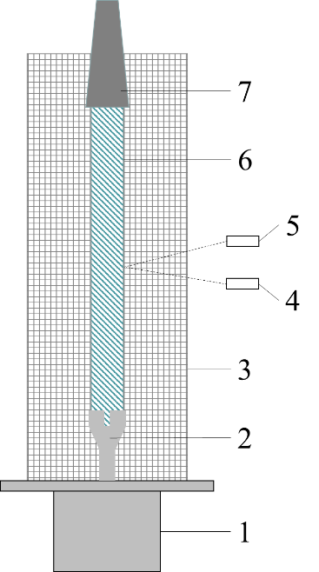
The results of measurements of the radiative characteristics of microwave electrodeless low-pressure argon-mercury lamps 10–2…2 Torr were presented. The experimental sheme is shown in the figure. Experimental setup: 1 – magnetron with a pulse power of 650…1500 W; 2 – internal electrode (collet type); 3 - metal mesh (1×1 cm); 4 - FEU-142, FEU-106; 5 – AvaSpec-S2000 spectrometer; 6 - mercury-argon lamp; 7 - microwave absorber. For absolute value of the intensity of UV radiation (254 nm) measurement an actinometry technique based on potassium feroxolate was used. With this method of excitation, the discharge was a system of contracted channels propagating along the surface of the quartz tube inside it. The dynamic radiative characteristics of the discharge and their dependence on the argon pressure were studied.
The characteristics were studied in two modes - cold and hot. Cold - single pulse mode, in which the temperature of the lamp was ~20 ℃, and the saturated mercury vapo pressure Prt = 1.22 * 10–2 Torr. Hot - repetitively pulsed mode with an average power of ~70 W, at which the lamp temperature reached ~100 ℃ and Prt = 0.271 Torr.
In the cold mode, the intensity of UV radiation was inversely proportional to the argon pressure in the lamp. In the hot mode, the intensity of UV radiation slightly increased with increasing argon pressure in the lamp.
The efficiency of the lamp in both regimes increased with decreasing magnetron power from 1500 W to 650 W. In this case, the type of discharge did not change.

*) abstracts of this report in Russian

