PLASMA WATER TREATMENT BY A DIRECT PIEZO DISCHARGE AND ITS DIAGNOSIS BY ABSORPTION IN THE UV RANGE *)
DOI: 10.34854/ICPAF.2023.50.2023.1.1.207
Artem’ev K.V., Davydov A.M., Malakhov D.V.
Prokhorov General Physics Institute of the Russian Academy of Sciences, Moscow, Russia
The production of long-lived reactive oxygen and nitrogen species in distilled water treated with low-temperature plasma of a direct (without a dielectric barrier) piezo-discharge [1] was studied. Long-lived reactive species include nitrate and nitrite ions (NO₃⁻, NO₂⁻), hydrogen peroxide (H₂O₂), and nitrous acid (HONO). The use of plasma treated water is widely researched in biomedical applications, agriculture and food industry [2].
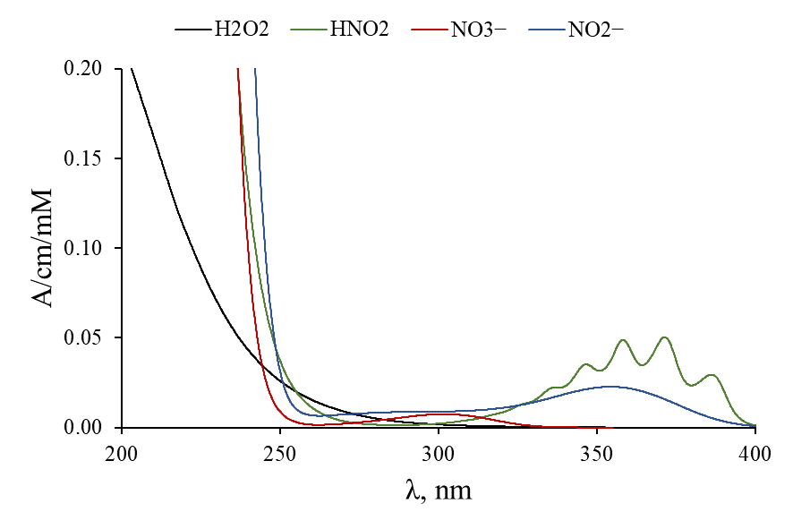
The method for diagnosing reactive species presented in the work is based on the absorption of photons in the range of 200–400 nm by them [3]. The absorption ranges of these species intersect, but the absorption spectra differ qualitatively from each other (see figure). This makes it possible to decompose the total absorption spectrum into components - the absorption spectra of each of the particles. This diagnostic method is non-invasive and allows you to simultaneously determine the concentration of reactive species.
A direct piezo discharge was generated in the air at atmospheric pressure above the water surface. Water treatment with a volume of 10 ml was carried out in a rectangular cuvette (2×5 cm) with quartz CU walls. A beam of diagnostic UV radiation passed through the cell along its larger side. The water treatment time was 8 minutes. During this time, it produced 240 μM NO₃⁻, 200 μM NO₂⁻, 140 μM HONO and 350...450 μM H₂O₂. Production of hydrogen peroxide depended on the humidity of the air.
In this work, we obtained data on the time dynamics of the concentrations of NO₃⁻, NO₂⁻, H₂O₂, and HONO particles both during discharge treatment and for 3 days after it.
References
- E.M. Konchekov, A.P. Glinushkin, V.P. Kalinitchenko, K.V. Artem’ev, D.E. Burmistrov, V.A. Kozlov and L.V. Kolik. Properties and use of water activated by plasma of piezoelectric direct discharge // Front. Phys., January 2021, Volume 8, Article 616385.
- Renwu Zhou et al. Plasma-activated water: generation, origin of reactive species and biological applications J. Phys. D: Appl. Phys. 53 303001. 2020.
- K. Tachibana and T. Nakamura. Examination of UV-absorption spectroscopy for analysis of O3, NO2−, and HNO2 compositions and kinetics in plasma-activated water // Japanese Journal of Applied Physics 59, 056004 (2020).

*) abstracts of this report in Russian

