activation of water solutions using a multi-spark ring discharge with gas injection in the discharge gap *)
DOI: 10.34854/ICPAF.2023.50.2023.1.1.210
^{1,2}Razvolyaeva D., ^{1,2}Gudkova V., ¹Konchekov E., ¹Moryakov I., ¹Anpilov A., ¹Berezhetskaya N., ^{1,2}Borzosekov V.
¹Prokhorov General Physics Institute of the Russian Academy of Sciences, Moscow, Russia,
gudkova-vi@fpl.gpi.ru
²Рeoples’ Friendship University of Russia, Moscow, Russia
In recent years, there has been increasing interest in the use of plasma-treated liquids in the agricultural industry. Active chemical compounds generated by plasma lead to a change and activation of physical and chemical properties, biochemical and molecular processes in plants. This promotes seed germination and disinfection, plant growth, insect control, agricultural product quality, and soil restoration, which together can lead to increased food production [1].
The dependence of the effect of the supplied gas (air, Ar) on the formation of reactive oxygen and nitrogen species in aqueous solutions is studied using a multi-spark ring discharge with gas injection in the discharge gaps. The discharge system consists of stainless steel electrodes arranged along the ring with the same spacing of 1.5 mm. A microplasma discharge is formed in each discharge gap [2]. Power source parameters: U ≤ 20 kV, I ≤ 300 A, f ≤ 50 Hz, W ≤ 1.6 J,
$V_{flow}=3 \frac{l}{min}$.
The aim of the research is to measure the concentrations of hydrogen peroxide (H₂O₂) and nitrite ions (NO₂⁻) during injection of air and argon in Milli−Q water shown in the figure. The obtained dependences of the operating time of active forms of oxygen and nitrogen on the duration of treatment will allow optimizing the effect of activated liquid on plants and planting material in future studies.
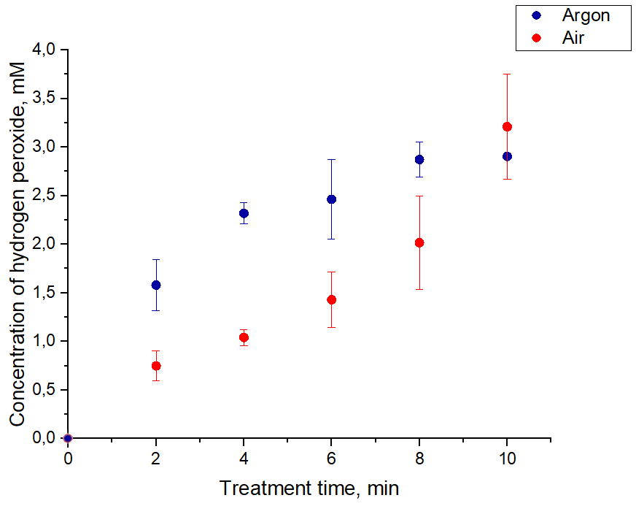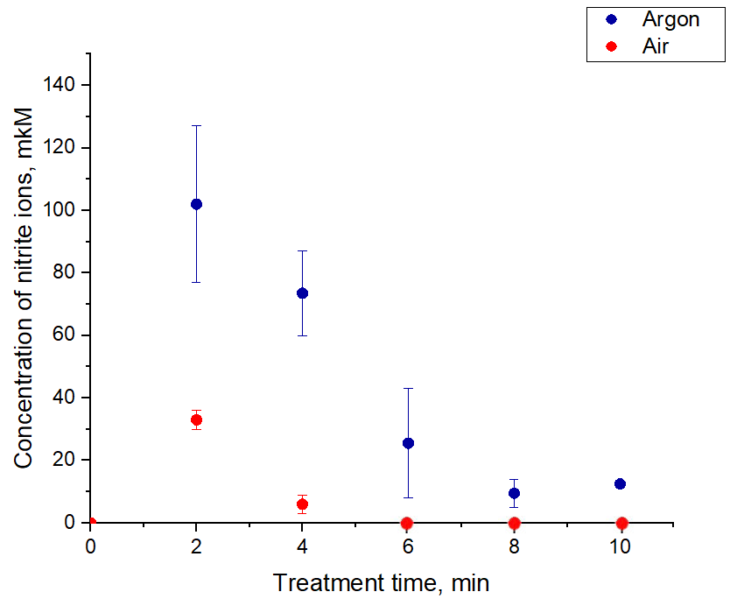
Figure. The concentration of hydrogen peroxide and nitrite ions in Milli-Q deionized water, depending on the duration of exposure to a multi-spark ring discharge with a stream of atmospheric air or argon.
References
- Dingmeng G, Hongxia L, Lei Z, Jinzhuo X, Chi H., J Sci Food Agric. 2021 Sep;101(12):4891-4899. doi: 10.1002/jsfa.11258
- Anpilov A.M., Barkhudarov E.M., Bark Y.B, Zadiraka Yu.V., Christofi N., Kozlov Y.N., Kossyi I.A. Kop’ev V.A, Silakov V.P., Taktakishvili M.I., Temchin S.M. 2001. JPhys. D: Appl Phys 34,993-999.

*) abstracts of this report in Russian

