CONTROL OF TNF-α CYTOKINE GENERATION USING PLASMA-ACTIVATED HANKS’ SOLUTION FOR ANTITUMOR THERAPY *)
DOI: 10.34854/ICPAF.2023.50.2023.1.1.205
^{1,2}Gudkova V., ^{1,2}Razvolyaeva D., ¹Konchekov E., ^{1,2}Borzosekov V., ^{1,3}Pavlik T.
¹Prokhorov General Physics Institute of the Russian Academy of Sciences, Moscow, Russia,
gudkova-vi@fpl.gpi.ru
²Рeoples’ Friendship University of Russia, Moscow, Russia, borzosekov-vd@rudn.ru
³Pirogov Russian National Research Medical University, Moscow, Russia,
ti.pavlik.u@gmail.ru
At present, research on the application of atmospheric pressure cold plasma in the treatment of oncological diseases is developing on a large scale. The increased interest in the use of non-equilibrium discharges at atmospheric pressure is caused by their unique plasma chemistry [1]. In this paper we investigate the effect of Hanks’ solution treated with cold direct piezo-discharge plasma [2] on the production of tumor necrosis factor by human mononuclear leukocytes. Under the influence of direct piezoelectric discharge in the solution, reactive oxygen and nitrogen forms are formed which affect redox processes in tumor cells, destroying them. Strong buffering properties of Hanks' solution were established earlier [3]: this solution maintains a neutral pH value (pH 7.6 ± 0.5) at the studied treatment times (2.5, 5, 7.5 min). The concentrations of hydrogen peroxide and nitrite ions were also found to depend on the treatment time using photocolorimetric methods.
The study compares the action of Hanks' cold plasma treated solution (PTS) with action of chemical solutions of $H_{2}O_{2}$ and ${NO}_{2}^{-}$. Hydrogen peroxide reduced TNF-α production in all concentrations studied, when added with nitrite ions it did not change TNF-α production compared with control. Hanks' solution treated with cold plasma for 2.5 min increased TNF-α production, and with longer treatment times, TNF-α production did not differ from controls. We can assume that treatment of Hanks’ solution in certain modes (2.5 min) creates in it a unique set of ROS that stimulates cells of the immune system to antitumor activity.
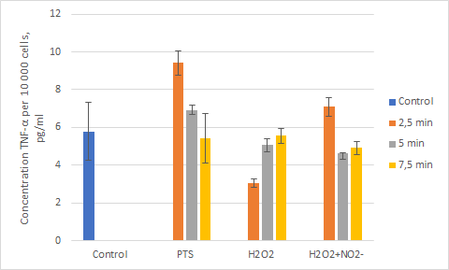
References
- Peter J Bruggeman et al. Foundations of atmospheric pressure non-equilibrium plasmas // Plasma Sources Science and Technology. – 2017. 26 123002.
- L.V. Kolik et al. Study of characteristics of the cold atmospheric plasma source based on a piezo transformer. Russian Physics Journal, Vol. 62, No. 11, March, 2020.
- Гудкова В.В., Павлик Т.И., Разволяева Д.А. «Прямой пьезоразряд как источник $H_{2}O_{2}$ и ${NO}_{2}^{-}$в водных растворах». Труды конф. «Радиоинфоком 2022». Москва, 2022, с. 278-282.

*) abstracts of this report in Russian

