APPLICATION OF A JET HF DISCHARGE IN A DYNAMIC VACUUM TO CREATE A COMPOSITE MATERIAL BASED ON UHMWPE AND A POLYURETHANE MATRIX *)
DOI: 10.34854/ICPAF.2023.50.2023.1.1.187
¹Abdullin I.Sh., ²Zheltukhin V.S., ¹Nekrasov I.K., ¹Sagitova F.R.
¹Plasma-VST LLC, plasma.vst@gmail.com,
²Kazan Federal University, igor05071997@mail.ru.
Research has been carried out on the use of a jet RF discharge under dynamic vacuum conditions to create a composite material using fibrous materials. The aim of the study was to increase the wettability of the fibrous material by modifying the surface in the plasma jet of an RF discharge.
Air was used as the plasma-forming gas, the pressure was varied from 13 to 133 Pa, the energy of ions entering the processed material was from 50 to 100 eV at an ion current density of 0.7 to 0.9 A/m2, the plasma generation frequency was set at 13.56 MHz, processing time ranged from 5 to 15 minutes. The description of the setup is presented in [1].
It has been established that the low-energy ion flow is the physical tool for processing in a jet RF discharge [1]. In this work, we compared the characteristics of CMs using RF plasma treatment based on UHMWPE and a polyurethane matrix (PEPU) and an epoxy matrix (PEE), and based on Rusar-S aramid fabric and an epoxy matrix (ARE) (Table 1). Figure 1 shows a side view of the KM.
Figure №1. Side view of a plasma treated CM based on UHMWPE and epoxy resin.
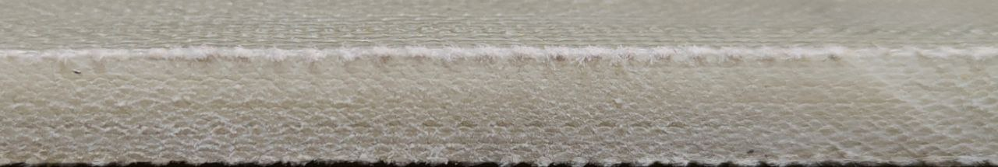
Table №1. Feature сomparison.
Feature | Material
 | PEPU | ARE | PEE
Breaking elongation, % | 4.1 | 2,6 | 3,6
Density, cm³ | 1,10 | 1,45 | 1,20
Specific module, km | 13305 | 5208 | 12005
Specific strength, Sn/Tex | 360 | 285 | 168
Thus, a composite material with high physical and mechanical characteristics was obtained.
References
- I.Sh. Abdullin, V.S. Zheltukhin, N.F. Kashapov. High-frequency plasma-jet processing of materials at reduced pressures. Theory

*) abstracts of this report in Russian

