STUDY OF THE EMISSION PROPERTIES OF THE SURFACE OF TUNGSTEN WITH A NANOSTRUCTURE OF THE "FUZZ " TYPE *)
DOI: 10.34854/ICPAF.2023.50.2023.1.1.177
¹Fedorovich S.D., ^{1,2}Budaev V.P., ¹Chilin M.S.
¹National Research University “MPEI”, fedorovichsd@mail.ru
²National Research Center “Kurchatov Institute”
One of the negative processes that affect erosion and serve as a source of plasma contamination is the formation of unipolar arcs (UA) when the surface is a cathode and an anode at the same time. Unipolar arcs can be predominantly generated on rough and inhomogeneous surfaces, including tungsten surfaces with a nanostructure of the "fuzz" type. Such surfaces from layers of nanofibers with a diameter of 20–50 nanometers are formed by irradiating tungsten with helium plasma during hourly discharges under special conditions for the flow of particles to the surface. In the PLM setup [1], when testing tungsten with stationary plasma flows, nanostructured layers of the “fuzz” type up to 1.5 micrometers thick are formed on the surface.
In this work, the emission properties of a modified tungsten surface with such a “fuzz” type nanostructure are studied [1]. The experiment was carried out using a sample with a surface area of ​​1.5 cm², uniformly covered with a "fuzz" type structure. The width of the interelectrode gap between the hemispherical surface of the anode and the sample is 0.3 mm. Negative potential in the range of 0 - 10 kV was applied to the sample (Figure 1 a). The vacuum chamber was evacuated to a residual gas pressure of 6·10⁻⁶ Torr. The results of the experiment in comparison with the data of work [2] are presented in Figure 1 b. The resulting electron emission current can cause explosive electron emission and erosion, which must be taken into account when operating thermonuclear installations.
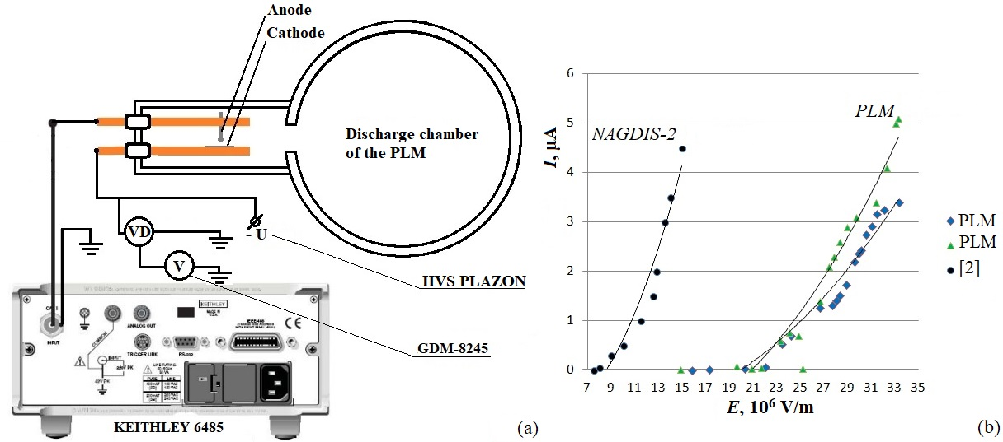
Figure 1 - Electrical circuit of measurements (a) and the dependence of the emission current on the field strength (b)
Plasma tests were carried out within the framework of the EOTP-UTP project 223 of the State Corporation "Rosatom", the analysis of materials was carried out with the support of the Ministry of Science and Higher Education of the Russian Federation FSWF-2020-0023, the assessment of radiation effects was carried out with the support of the RFBR grant 19-29-02020.
References
- Budaev V. P. et al. VANT ser. Thermonuclear fusion. - 2017. - Vol. 40, No. 3. - P. 35.
- Hwangbo D. at al. IEEE Trans. Plasma Sci. – 2017. Vol. 45, No. 8. – P. 2080.

*) abstracts of this report in Russian

