DEPOSITION OF THIN FILMS OF REFRACTORY METALS ON GLASS THROUGH DIAPHRAGM IN A PLASMA FOCUS FACILITY *)
DOI: 10.34854/ICPAF.2023.50.2023.1.1.183
¹Borovitskaya I.V., ²Gaidar A.I., ¹Kolokoltsev V.N., ¹Kobeleva L.I., ³Mezrin A.M., ⁴Nikulin V.Ya., ⁴Silin P.V.
¹Institute of Metallurgy and Materials Science. A.A. Baikov of RAS, Moscow, Russia,
v.kolokotsev@yandex.ru
²Research Institute of Advanced Materials and Technologies, Moscow, Russia, a_i_g@bk.ru
³Ishlinsky Institute for Problems in Mechanic, of RAS, Moscow, Russia, amezrin@rambler.ru
⁴Lebedev Physical Institute of RAS, Moscow, Russia, lfpp@mail.ru
The aim of the work was to obtain thin films of refractory metals: Mo, W, and Ta of small sizes (<5 mm) on glass substrates using a Plasma Focus (PF) setup. We used a PF-4 facility (LPI) with coaxial electrodes and an energy stored in a capacitor bank of ~3.2 kJ. Metal films were deposited on glass substrates through metal diaphragms with holes 2.5, 3.5, and 4.5 mm in diameter. The diaphragm size was determined by the possibility of obtaining sufficiently homogeneous films on substrates at a given stored energy in the PF-4 setup. The sample holder and diaphragms were made of X18N10T stainless steel. The thickness of the metal foils was chosen in such a way that complete melting and evaporation of the metal took place during the action of one plasma pulse. The thickness of the foils was <50 µm. The working gases were argon (Ar) and nitrogen (N2) at a pressure of ~1 Torr in the working chamber. Silicate glass substrates ~20x20 mm in size were made from photographic plates ~ .5–2.0 mm thick. The substrates were washed with ethanol and distilled water. Metal films were studied using an EVO-40 scanning microscope with an X-ray microanalyzer, a 3D model S Neox optical profilometer from Sensobar-Tech, SL, an XP-200 digital profilometer from AMBIOS, and a Leica DM optical microscope. Figure 1a,b,c shows a typical pattern of the distribution of metal particles and the elemental composition of the Ta film.

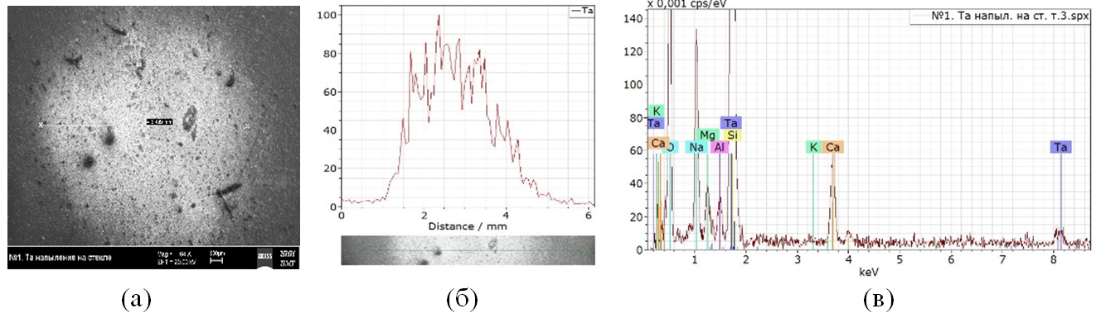
Fig. 1. Tantalum film on a glass substrate (scanning microscope EVO-40): (a) - region of Ta deposition; (b) - relative Ta concentration in the deposition area; (c) - elemental composition of the film.
The average thickness of metal films on substrates ranged from a few to ~10 μm. High adhesion of metal films to glass substrates was achieved due to the deep penetration of particles under the glass surface at a high plasma jet velocity >10⁷ cm/s. It should be noted that the deposited films consist of individual metal particles ranging in size from tens to hundreds of nanometers and, therefore, their properties differ significantly from films obtained by the magnetron method.
The work was carried out in accordance with state assignments No. 075-00715-22-00 and 0023-2022-0004.

*) abstracts of this report in Russian

