ANALYSIS OF NEUTRON RADIATION GENERATED IN THE COUNTER INTERACTION OF HIGH ENERGY DeUTERIUM PLASMA FLOWS IN A MAGNETIC FIELD *)
DOI: 10.34854/ICPAF.2023.50.2023.1.1.188
^{1,2}Burmistrov D.A., ¹Gavrilov V.V., ¹Zharova A.A., ¹Zhitlukhin A.M., ^{1,3}Lidzhigoryaev S.D., ^{1,3}Toporkov D.A.
¹SRC RF TRINITI, Troitsk, Russia, liner@triniti.ru
²Moscow Institute of Physics and Technology (National Research University), Dolgoprudny,
Russia, info@mipt.ru
³National Research University MPEI, Moscow, Russia, universe@mpei.ac.ru
The study of the D–D interaction of plasma flows was carried out on a 2MK-200 experimental setup, consisting of two electrodynamic accelerators with pulsed gas injection, installed at a distance of 3 m from each other. The operating voltage varied from 16 to 24 kV [1]. The accelerators were connected by a plasma pipeline with a diameter of 219 to 166 mm with a narrowing in the middle. With the help of multi-turn solenoids, a quasi-stationary magnetic field was created in the plasma pipeline by induction from 1 to 2 T to the center of the liner.
In the experiments, the integral neutron yield per pulse was determined using indium and silver activation sensors based on SBT10A counters placed in a polyethylene moderator block.
To restore the neutron yield, in addition to the calibration value, we used an approximation of the decay exponent in the detector when the half-life of the active element is known. That is, the signal from the detector was approximated by the function: ∆N=N0 (1-e^(-λδ)) e^(-λt), from which the number of activated silver nuclei N0 was calculated, which is proportional to the neutron yield.
Figure 1 shows a typical silver decay curve obtained during an experiment with a capacitor bank voltage of 16 kV.
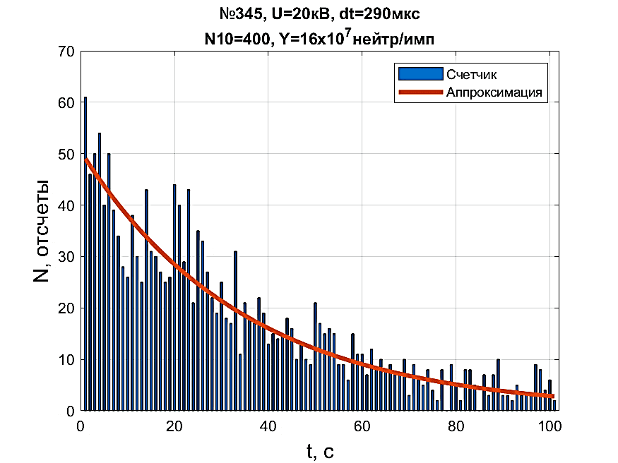
Figure 1 - Response of the activation detector, corresponding to 1.6 108 neutron/pulse
In the operating modes of accelerators with capacitor bank voltage U > 20 kV, the head part of the flow was a source of intense neutron radiation. The neutron yield during the flight time of 5-10 µs reached N ~ 1010 neutrons.
References
- Zhitlukhin A.M., Ilyushin I.V., Safronov V.M. Plasma Physics. 1982. V 8. 508-518

*) abstracts of this report in Russian

