Dynamics of Radiation of Nanosecond Discharges in Supersonic Air Flows with Shock Waves *)
DOI: 10.34854/ICPAF.2023.50.2023.1.1.174
Mursenkova I.V., Ziganshin A.F., Liao Yu., Ivanova A.A.
M.V. Lomonosov Moscow State University, Faculty of Physics; 119991 Moscow, Leninskie Gory; murs_i@physics.msu.ru
Discharges in high-velocity gas flows have been actively studied over the past decades in plasma aerodynamics [1, 2]. Modern research is determined by the requirement to determine the specific mechanism of the discharge plasma influence on high-speed flows. The dynamics of the radiation of nanosecond surface sliding discharge [3] and combined volume discharge [2] in structured supersonic air flows with Mach numbers of 1.16-1.70 is experimentally studied. Discharges with a duration of ~500 ns were initiated in the discharge chamber of a shock tube [2, 3]. The discharge radiation was analyzed on the base of registration with a nanosecond resolution by a K011 BIFO ICCD camera [2, 3]. The current and emission spectrum of the discharge were also recorded.
It has been experimentally shown that in inhomogeneous gas flows with shock waves, the dynamics of discharge radiation is affected by the structure of the density distribution in the discharge region. Figure 1 shows a nine-frame image of the glow of a surface sliding discharge in a flow with an oblique shock wave, which shows a nonmonotonic change in the discharge radiation intensity with a total duration of more than 4 μs. Due to the spatial inhomogeneity of the energy input, shock-wave configurations are formed that interact with the gas-discharge plasma [2, 3]. As a result, the flow structure in the channel changes within 100 μs.
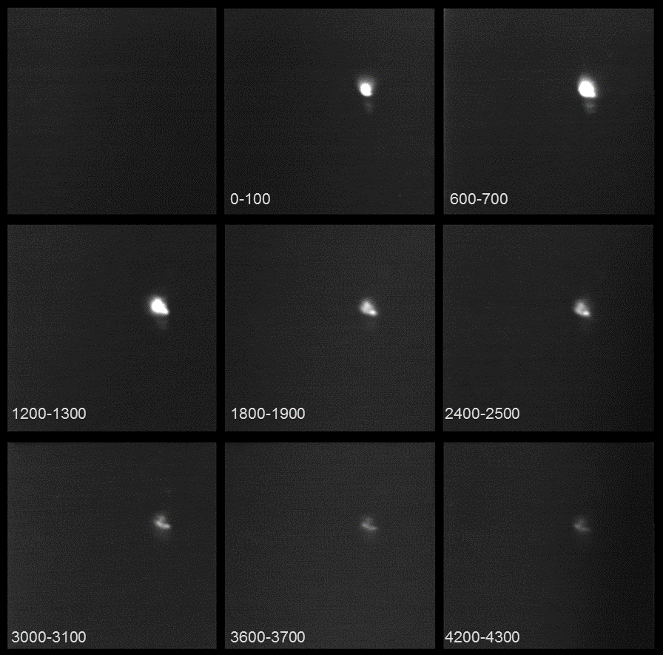

Fig. 1. Nine-frame image of a surface sliding discharge in a flow with an oblique shock wave. The flow Mach number is 1.58, the density is 0.06 kg/m3. The time is indicated on the frames in nanoseconds.
The Program for development of the Moscow State University supported this study.
References
- Starikovskiy A.Yu., and Aleksandrov N.L. Gasdynamic Flow control by ultrafast local heating in a strongly nonequilibrium pulsed plasma. Plasma Physics Reports. 2021. Vol. 47. P. 148–209
- Doroshchenko I.A., Znamenskaya I.A., Kuznetsov A.Yu., Mursenkova I.V., Sysoev N.N. Analysis of Plasmadynamic Nanosecond-Range Processes in the Formation of Shock Waves from Pulsed Discharges. Technical Physics, 2018. V. 63, No. 5, pp. 662–669
- Mursenkova I.V., Kuznetsov A.Yu., and Sazonov A.S. Unsteady interaction of nanosecond surface sliding discharge with plane shock wave. Appl. Phys. Lett., 2019. Vol. 115, No 11. 114102.

*) abstracts of this report in Russian

