Cooling of the zone of discharges sliding over the surface of a dielectric *)
DOI: 10.34854/ICPAF.2023.50.2023.1.1.180
Znamenskaya I.A., Kornozova E.A., Rudenko S., Doroshenko I.A.
Faculty of physics, Lomonosov Moscow State Univercity, znamen@phys.msu.ru
Practical interest in discharges sliding over dielectic surface is associated with the problem of isolation (increase in electrical strength of a surface), exclusion of the conditions for the appearance of the discharge plasma (for instance on a skin of aircraft), with the possibility of using a surface discharge to control high-speed fluid flows both in combustion chambers and on streamlined surfaces.
When looking at a discharge sliding over a dielectric surface one has to take into account the substrate material, wettability and conductivity of its surface. Main reasons for the deterioration of external insulation (decrease in breakdown voltage) are dielectric surface contaminations, the role of which are especially noticeable in a presence of moisture.
In this work, the following conditions for the development of discharges were studied:
1. Discharge sliding over the surface of a dielectric near dielectric insert on a horizontal surface of a plasma sheet; 30 mm in length.
2. Vertical column-shaped discharge near the discharge chamber window (volume discharge contraction mode), 24 mm in height
Shooting was carried out through the quartz windows of the discharge chamber of the shock tube.
Shadow high-speed shooting made it possible to register cylindrical shock waves from the area of pulsed linear energy storage near vertical and horizontal walls, to measure the velocity [1].
Sequential images of infrared fields heated by nanosecond-duration discharges of the chamber walls were obtained, the relaxation time of thermal radiation of the walls near a dielectric insert in the form of a rectangular parallelepiped measuring 6 × 2 × 48 mm3 was investigated. It is shown that the cooling time of the textolite wall area heated by plasma can last up to 30 ms and significantly exceeds the cooling time of the quartz wall (up to 4 ms).
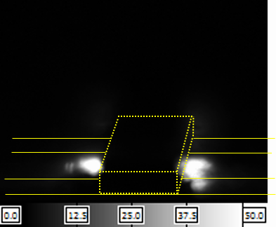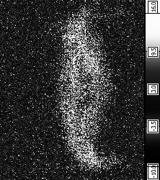
Fig. 1. Infrared survey of the heated wall on the left and the camera window on the right
The work was supported by the RGNF grant 22-29-00652
References
- Kuzmin G.P., Minaev I.M., Rukhadze A.A. Flow around a viscous gas flow of a plasma sheet formed by a sliding discharge // Applied Physics. - 2004. - No. 6. - pp. 96-104. (Кузьмин Г.П., Минаев И.М., Рузадзе А.А. Обтекание вязким потоком газа плазменного листа, образованного скользящим разрядом // Прикладная физика. - 2004. - No 6. - С. 96-104. in Russian)

*) abstracts of this report in Russian

