Tokamak T-15MD Facility 3D-model verification based on the results of the laser geodetic scanning *)
DOI: 10.34854/ICPAF.2023.50.2023.1.1.086
^{1,2}Shelegeda I.A., ¹Drabinskiy M.A.
¹NRC “Kurchatov Insititute”, nrcki@nrcki.ru
²Bauman Moscow State Technical University (NRU), bauman@bmstu.ru
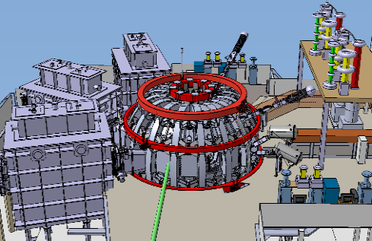
When developing the tokamak T-15MD complex (its diagnostics, heating systems, auxiliary technical systems), it is proposed to use the joint design of individual assemblies in three-dimensional computer-aided design systems. The 3D-model of T-15MD used for that purpose is shown in figure 1. The reference point for this approach is the use of this method in the development of the International Thermonuclear Experimental Reactor (ITER). The practice of its creation has shown that a large number of factors must be taken into account when developing an experimental facility of high complexity, including the possibility of placing a large number of systems in a limited space at the same time without conflicts, access to all structural elements for their maintenance, as well as safety requirements. The use of a single three-dimensional model makes it possible to take these factors into account. Independent teams from around the world are engaged in the development of various ITER systems [1]. All systems are built into the single three-dimensional model of ITER. This approach allows individual teams to carry out coordinated designing based on data on the location of components of adjacent systems and parts of the tokamak structure. Thus, conflict-free placement of different systems is ensured and the development process is accelerated.
Fig. 1 3D-model of the T-15MD facility
However, this method also has a number of disadvantages, the most important of which is the possible discrepancy between the design elements in the three-dimensional model and the real elements of the tokamak and its systems. Possible reasons for the discrepancy between the three-dimensional model and the real design of the installation are the change or replacement of elements of the real construction or inaccuracy of parts manufacturing.
The report presents a way to take into account these drawbacks during the development of the T-15MD complexes, based on the verification of the three-dimensional model with the data of laser geodetic scanning, which allows to conduct measurements with an error of 1-3 mm. The results of scanning, presented in the form of a point cloud, became the basis for specifying the dimensions and location of the T-15MD design elements and additional tokamak systems. Consideration of the above parameters will allow to develop the tokamak systems in such a way as to meet the requirements for safety, ergonomics, accessibility of equipment for repair and maintenance.
References
- F. Louche et al. 3D modeling and optimization of the ITER ICRH antenna // AIP Conference Proceedings 1406, 69 (2011);
- Drabinskiy M.A. et al. 3D model of the T-15MD TOKAMAK complex // XLIX International Zvenigorod conference on plasma physics and controlled fusion ICPAF-2022. Book of abstracts (2022)

*) abstracts of this report in Russian

