2d distribution of electric potential in the t-10 tokamak ohmic plasmas *)
DOI: 10.34854/ICPAF.2023.50.2023.1.1.084
^{1,2}Ammosov Y.M., ³Khabanov P.O., ¹Drabinskiy M.A., ^{1,2,4}Melnikov A.V., ¹Eliseev L.G., ^{1,5}Kharchev N.K., ¹Lysenko S.E.
¹NRC “Kurchatov Institute”, nrcki@nrcki.ru
²Moscow Institute of Physics and Technology (NRU), info@mipt.ru
³University of Wisconsin-Madison, onwisconsin@admissions.wisc.edu
⁴National Research Nuclear University “MEPhI”, info@mephi.ru
⁵Prokhorov General Physics Institute, office@gpi.ru
The study of heat and particle transport mechanisms in plasmas of toroidal devices is one of the key issues in hot plasma physics. One of the transport regulation mechanisms are ExB shear flows induced by the radial electric field, thus the experimental study of the spatial distributions of the electric potential is an important problem.
The first attempts to measure 2D distributions of the plasma potential by heavy ion beam probe (HIBP) were made in an ECRH plasmas at the LHD (Japan) [1, 2] and TJ-II (Spain) [3] stellarators. Then, detailed 2D distributions of the potential and its oscillations were measured on the TJ-II in the regimes with ECRH and NBI, which have shown that the equipotential lines are consistent with the vacuum magnetic flux surfaces of the device [4].
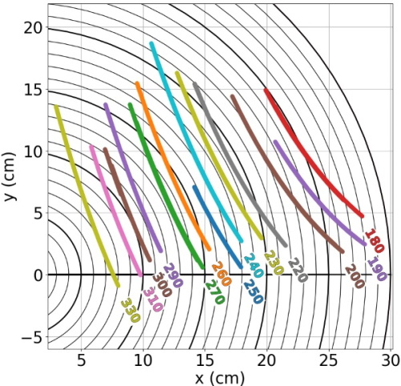
Fig. 1 Measurement region of the electric potential. Detector lines of equal energy for cesium ions in the Eb = 180-330 keV range are shown.
T-10 Tokamak (R = 1.5 m, a = 0.3 m, B_{t} ≤ 2.5 T, I_{pl} ≤ 300 kA, ${\overline{n}}_{e}$ ≤ 6ꞏ10¹⁹ m⁻³) is equipped with the HIBP diagnostic which allows to measure the electric potential and its fluctuations, as well as fluctuations of the density and magnetic potential in the hot plasma region [5].
2D distribution of the electric potential in an ohmic plasma with the magnetic field B_{t} = 2.2 T, plasma current I_{pl} = 230 kA, averaged-line electron density ${\overline{n}}_{e}$ = 1.1ꞏ10¹⁹ m⁻³ is presented. The potential measurements were made in the first quadrant of the plasma cross section (Fig. 1).
It was found that in this T-10 tokamak regime:
- the potential distribution is consistent with the vacuum magnetic flux surfaces of the device;
- in the central plasma region the potential has a value φ(r/a = 0.24) ≈ -1500 V;
- at the periphery of the plasma the potential has a value φ(r/a = 0.9) ≈ +170 V.
References
- Shimizu A. et al. // Rev. Sci. Instrum., 2014. V. 85. № 11. P. 11D853-1.
- Shimizu A. et al. // Rev. Sci. Instrum., 2016, V. 87, № 11, P. 11E731.
- Sharma R. et al. // Phys. Plasmas, 2020. V. 27. P. 062502.
- Melnikov A.V. et al. // Plasma Phys. Control. Fusion, 2022. V. 64. № 5. P. 054009 (10pp).
- Melnikov A.V. et al. // Fusion Eng. Des., 2019. V. 146. P. 850-853.

*) abstracts of this report in Russian

