Temperature dependency of the GAM and its satellites frequency In T-10 tokamak plasmas *)
²Krokhalev O.D., ^{1,2,3}Melnikov A.V., ¹Drabinskiy M.A., ¹Eliseev L.G.
¹NRC “Kurchatov Institute”, Moscow, Russia, nrcki@nrcki.ru
²Moscow Institute of Physics and Technology, Moscow, Russia, info@mipt.ru
³Moscow Engineering Physics Institute, Moscow, Russia, info@mephi.ru
Geodesic acoustic mode, which is high-frequency counterpart of zonal flows, in T-10 tokamak plasmas has three-peak frequency structure [1]. For each of three peaks radial constancy of amplitude and frequency has been shown [2].
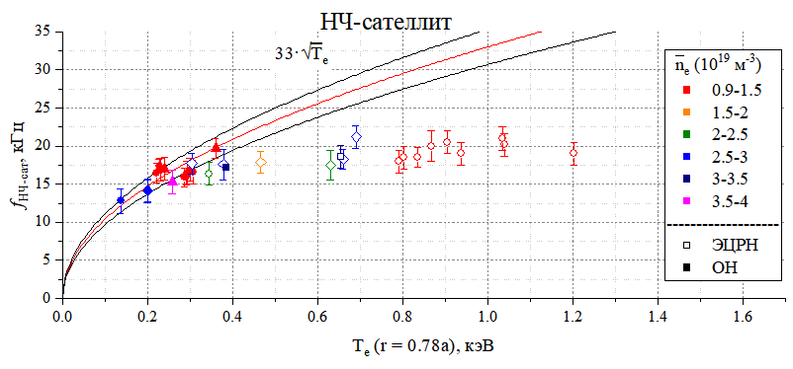
This paper presents research of GAM in T-10 tokamak, made with heavy ion beam probe [3]. Electron temperature was measured with second harmonics of ECE and soft-roentgen. A new method of spectra approximation by the sum of three Gaussians, corresponding to the main peak, the HF-satellite and the LF-satellite, was applied; approximate frequencies were determined from data, measured in other radial position in the same regime. This method increased reliability of spectrum separation and allowed to plot temperature dependencies of GAM and its satellites frequencies in wide variety of regimes with n_{e} = 0.9-4.3∙10¹⁹ m⁻³, Т_{е}(0) = 0.9-3.5 keV, including regimes with intense ECR heating: B_{tor} = 2.3 T, I_{pl} = 220-230 kA, P_{ECRH} = 2.2 MW. Was shown, that the square root dependency of frequency on temperature is valid not only for main GAM peak, but also for both satellites in a wide range of T_{e} = 0.9-2.0 keV. Further temperature raise leads to saturation of dependency f (T_{e}), and the electron temperature from which frequency saturates is individual for each peak. Comparison of experimental dependencies with predictions of two models – modified two-fluid MHD ($f_{GAM}^{e} = \frac{1}{\sqrt{2m_{i}}πR}\sqrt{T_{e}}$) and single-fluid Winsor ($f_{GAM}^{W} ≅ \sqrt{\frac{γT_{e}}{2m_{i}}}∙\frac{1}{πR}$) with varied from 1 to 5/3 adiabatic constant γ – showed that selected models do not predict the saturation of GAM and its satellites frequency.
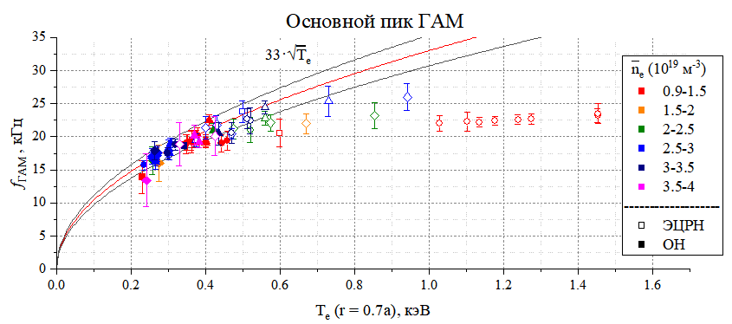
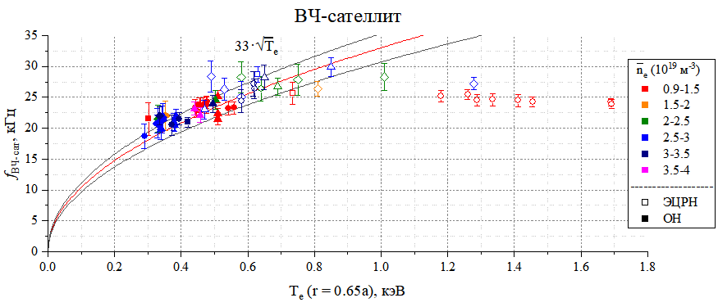

References
- Крохалев О.Д., Мельников А.В. // Труды 63 всероссийской научной конференции МФТИ – 2020 – стр. 215-217
- Krokhalev O.D. et al // 49 Zvenigorod international conference on plasma physics and controlled fusion, abstract series – ISBN 978-5-6042115-6-4 – 2022
- Melnikov A.V. et al. // Nuclear Fusion 2017 57 (6) 072004.

*) abstracts of this report in Russian

