simulation of the ohmic regimein the t-15md tokamak based on the canonical profile transport model *)
DOI: 10.34854/ICPAF.2023.50.2023.1.1.054
^{1,2}Kasyanova N.V., ¹Dnestrovskij Yu.N., ^{1,2,3}Melnikov A.V.
¹NRC “Kurchatov Institute”, Moscow, Russia, Kasyanova_NV@nrcki.ru
²Moscow Institute of Physics and Technology, Dolgoprudny, Russia
³NRNU MEPhI, Moscow, Russia
In this work, the ohmic discharges are simulated at the first stage of the T-15MD tokamak operation with reduced values ​​of the magnetic field B = 1 – 1.8 T and the plasma current I < 1.5 MA. We consider plasmas with a circular configuration (elongation k = 1, triangularity δ = 0 and a small radius a = 0.67 m).
The standard transport model of canonical profiles [1] is used for calculations. Equations are solved for the electron temperature T_{e}, ion temperature T_{i} and current diffusion. The plasma density profile is set in such a way that the normalized calculated pressure profile p(ρ)/p(0) constructed in the normalized coordinates ρ = r/(IR/kB)^{1/2} is the same in all modes, as observed in experiments on different tokamaks [2]. The dependence of the electron and ion temperatures on the average density is considered in a wide range of values $\overline{n_{e}}$​​ < 0.8n_{Gr} (where n_{Gr} =I/πa² is the Greenwald density).
Using the concept of equivalence of pairs of discharges for different tokamaks [1], the calculated profiles of the electron temperature in the T-15MD tokamak are compared with the experimental profiles obtained on the T-10 tokamak in discharges with low values ​​of the toroidal magnetic field (B = 1.7 – 2.1 T).
The comparison shows that the RMS deviations between the normalized equivalent experimental and calculated electron temperature profiles are ~ 6-8%
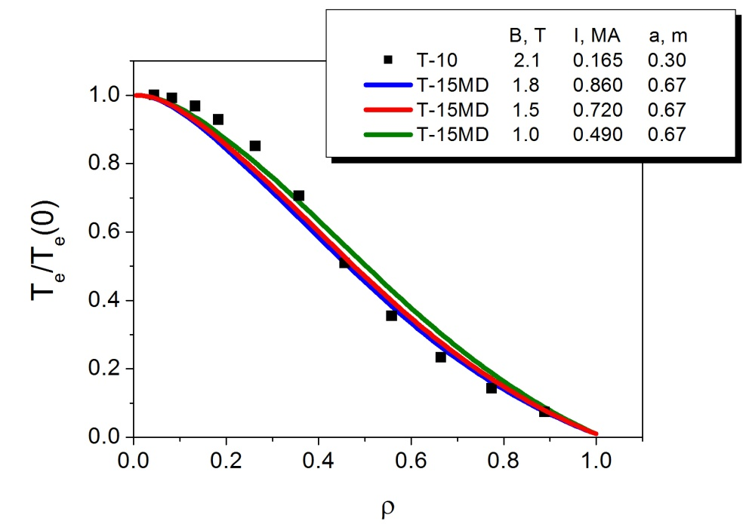
Fig.1. Normalized profiles of electron temperature in the ohmic mode: calculated profiles (T-15MD) for different values ​​of the toroidal field, plasma current and experimental profile (T-10), edge safety factor q_{a} = 4.
References
- Dnestrovskij Yu.N., at al. VANT. Ser. Thermonuclear Fusion, 2022, v. 45, iss. 1
- Razumova K.A., et al. Nucl. Fusion. 49 (2009) 065011

*) abstracts of this report in Russian

