MULTICHANNEL X-RAY SPECTROMETER for TOKAMAK T-15MD *)
DOI: 10.34854/ICPAF.2023.50.2023.1.1.037
¹Ideal R., ²Ryzhakov D.V., ^{1,2}Budaev V.P.
¹NRU “Moscow Power Engineering Institute”, Moscow, Russia, IdealR@mpei.ru ,
²NRC “Kurchatov Instiпtute”, Moscow, Russia, ryzhakov_dv@nrcki.ru.
To measure the profile of the absolute value of the electron temperature of a plasma cord in a tokamak, it is necessary to develop multi-channel diagnostics for X-ray registration.
In this work, the calculation of X-ray radiation from tokamak plasma was carried out in order to develop a diagnostic "Multichannel X-ray spectrometer" for tokamak T-15MD and a diagnostic scheme (Fig.1) was developed using experimental measurement results on tokamak T-10. From the comparison of calculated and experimental data, the dependence of the absorption of X-ray radiation in the detector (the spectral sensitivity of the detector) on the energy of the recorded radiation was determined, the geometric dimensions of the diagnostics designed for T-15MD were selected, the characteristics of filters and detector were clarified, a program was written that automatically approximates experimental data and determines the temperature of electrons. It was shown that with the selected diagnostic parameters, a good spatiotemporal resolution is expected for measurements at T-15MD. Diagnostics will allow measuring the characteristics of the plasma when registering quanta in the range from 2 keV to 15 keV.
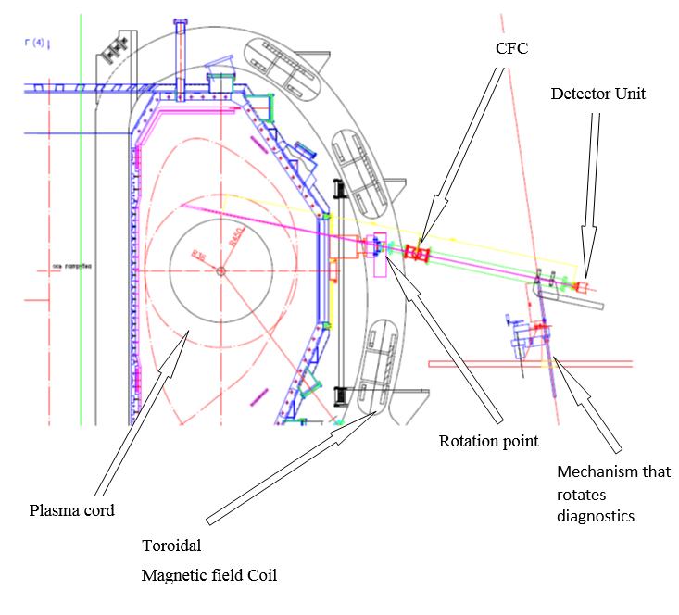
Fig. 1. Diagnostic measurement scheme on T-15MD (CFC - collimator and filter changer).
References
- Experimental thermonuclear installation tokamak T-15MD /P.P. Khvostenko et al. // VANT. Ser. Thermonuclear fusion. – 2019. – vol. 42, in .1. – pp. 15-38.

*) abstracts of this report in Russian

