CALCULATION OF THE DIFFUSION COEFFICIENT AND THE PARTICLE PINCH VELOCITY AFTER THE CENTRAL ECR HEATING ON THE T-10 *)
DOI: 10.34854/ICPAF.2023.50.2023.1.1.023
Aseev A.S., Andreev V.F., Danilov A.V., Dnestrovskij Yu.N.
NRC “Kurchatov institute”, Savuyor@gmail.com
In many experiments with on-axis ECR heating on the T-10 tokamak, particles are carried out from the heating zone to the plasma periphery [1]. This effect is called “density pump-out”. For the study of the “density pump-out” effect, two series of experiments are analyzed. The first series is a “standard” chamber; the second series is a “clean” chamber, after litization. Note that, in this case, the particle flux from the wall decreases significantly.
For each series of experiments, the diffusion coefficient and the particle pinch velocity in the transient process after switching on the central ECR heating are calculated. Two inverse problems are solved [2]. The first one is at a steady state in the ohmic regime, at a given diffusion coefficient, and the particle pinch velocity and the source are found from the solution of the inverse problem.
The second one is for the transient process after switching on the ECR heating at a fixed source of particles, and the diffusion coefficient and the particle pinch velocity are found from the solution of the inverse problem. In this case, the particle source is set to the one found at the station in the ohmic regime.
Comparison of the transport coefficients at the steady state and at the dynamic stage allows us to conclude that, after switching on the ECR heating, the removal of particles to the periphery is mainly determined by the change in the particle pinch velocity.
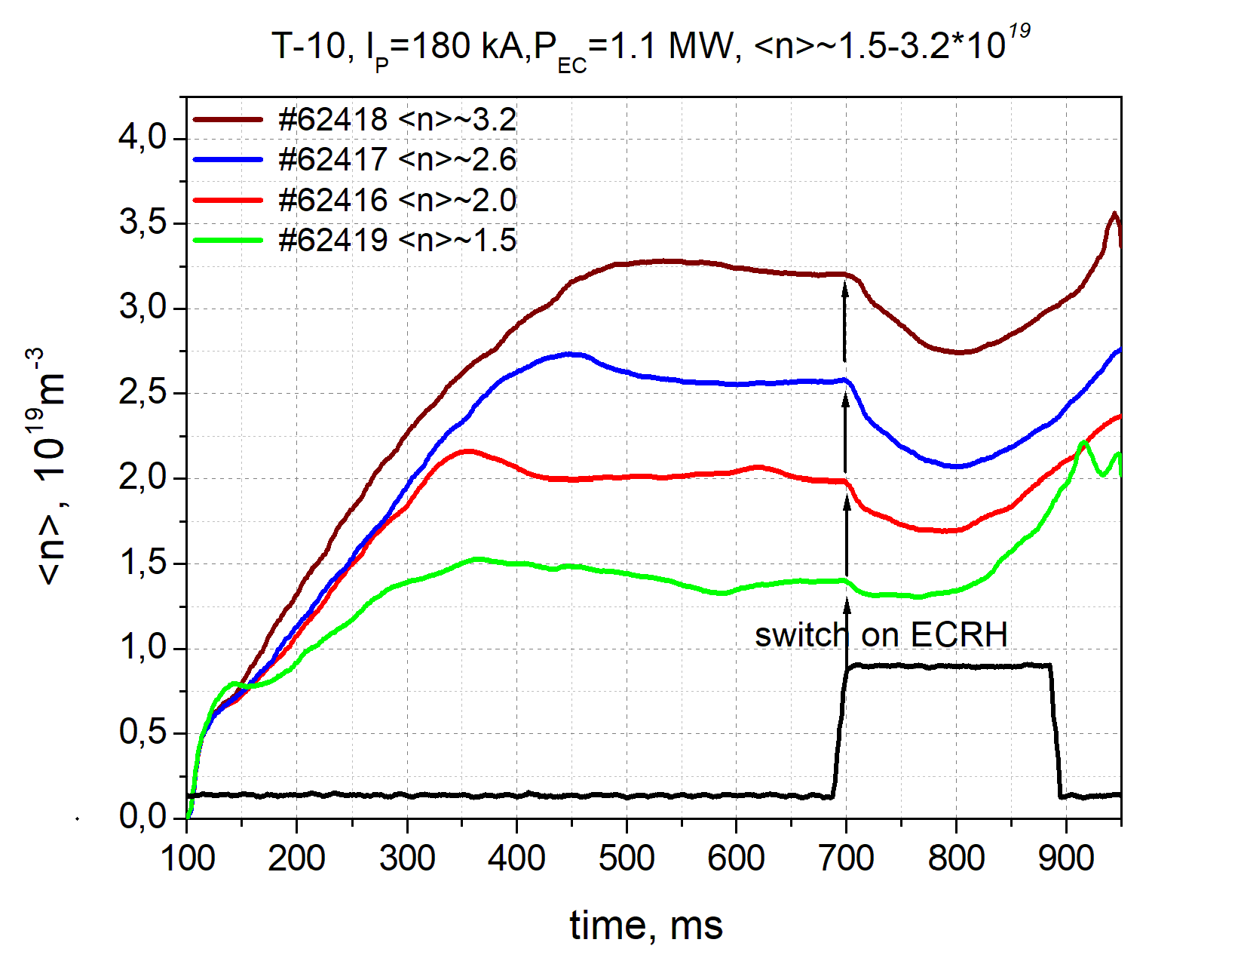 | 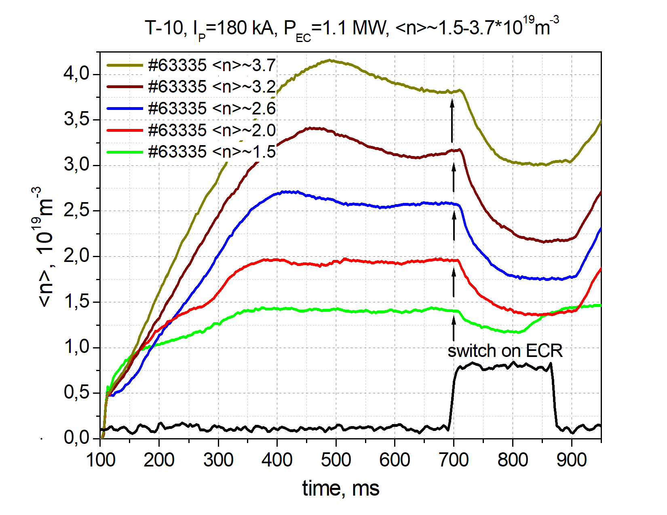
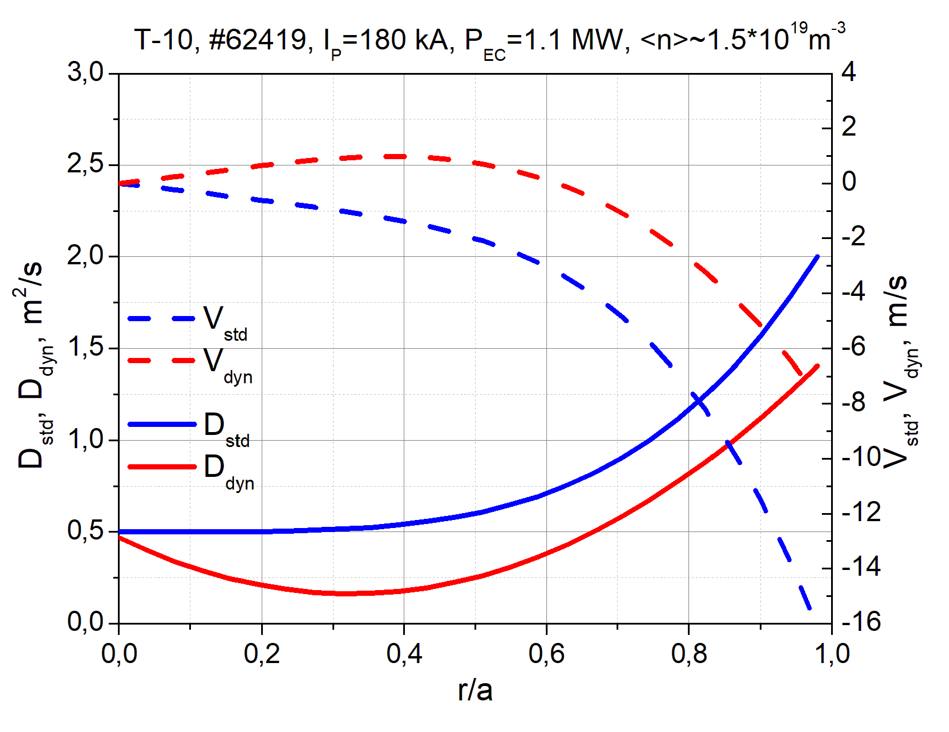 | 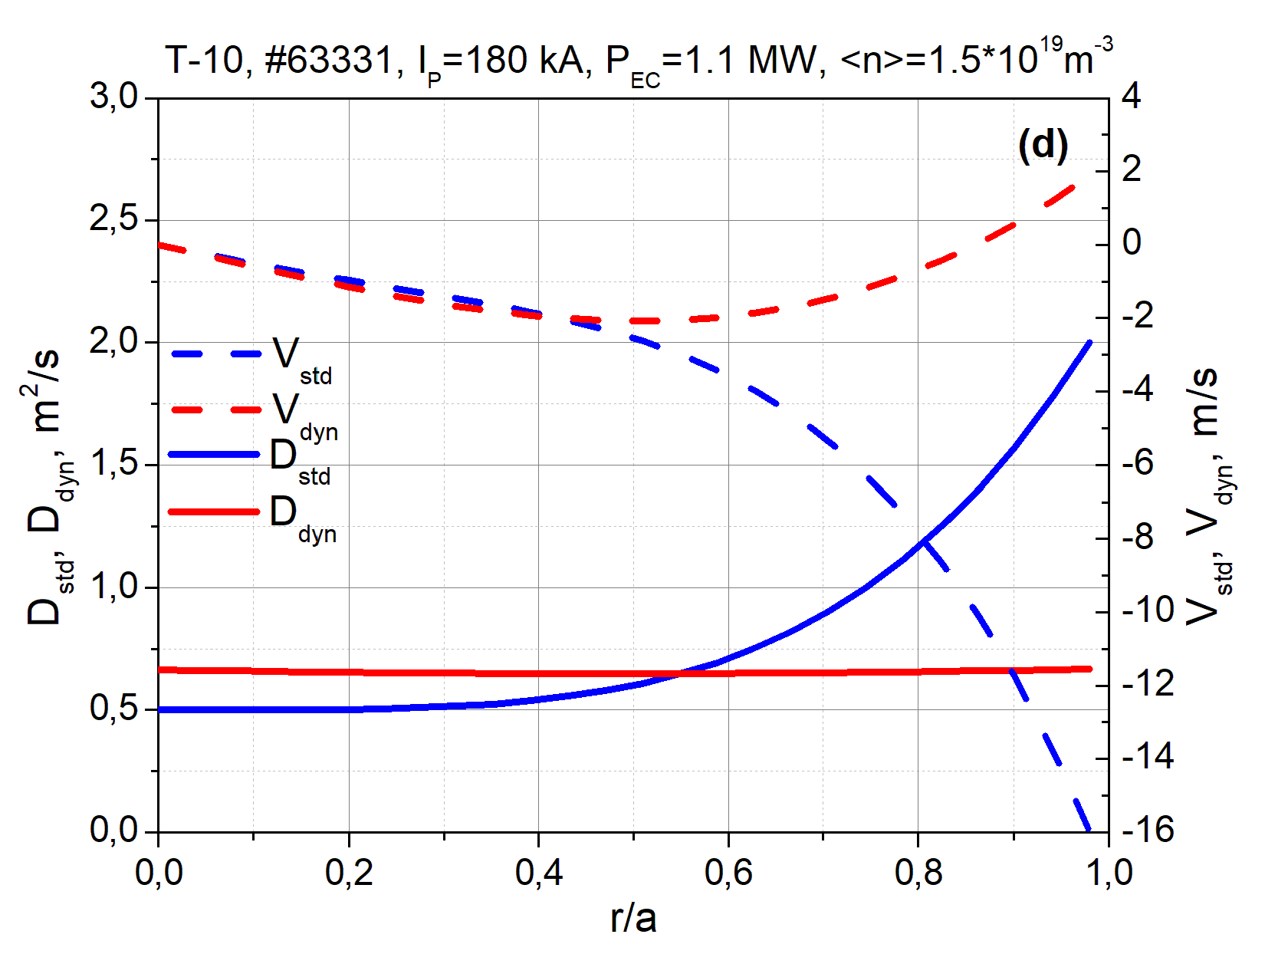
Figure 1. (a), (b) evolution of the integral density for the 1st and 2nd series of experiments; (c), (d) diffusion coefficient D and particle pinch velocity V for OH (std) and ECR (dyn) regimes for the 1st and 2nd series of experiments
References
- V.F Andreev et al. – Plasma Phys. and Control. Fusion, 2016, 58, 055008 (12pp)
- Kasjanova N.V., Andreev V.F. — VANT. Ser. Thermonuclear fusion, 2012, N. 4, p. 71

*) abstracts of this report in Russian

