LONG-RANGE CORRELATIONS OF ELECTRIC POTENTIAL IN THE TJ-ii STELLARATOR PLASMAS EDGE *)
DOI: 10.34854/ICPAF.2023.50.2023.1.1.022
^{1,2}Sarancha G.A., ¹Drabinskii M.A., ¹Eliseev L.G., ³Khabanov Ph.O., ^{1,4}Kharchev N.K., ^{1,2}Krokhalev O.D., ^{1,2,5}Melnikov A.V., ^{1,2}Naumenko P.R.
¹NRC “Kurchatov Insititute”, nrcki@nrcki.ru
²Moscow Institute of Physics and Technology (NRU), info@mipt.ru
³University of Wisconsin-Madison, onwisconsin@admissions.wisc.edu
⁴Prokhorov General Physics Institute, office@gpi.ru
⁵National Research Nuclear University “MEPhI”, info@mephi.ru
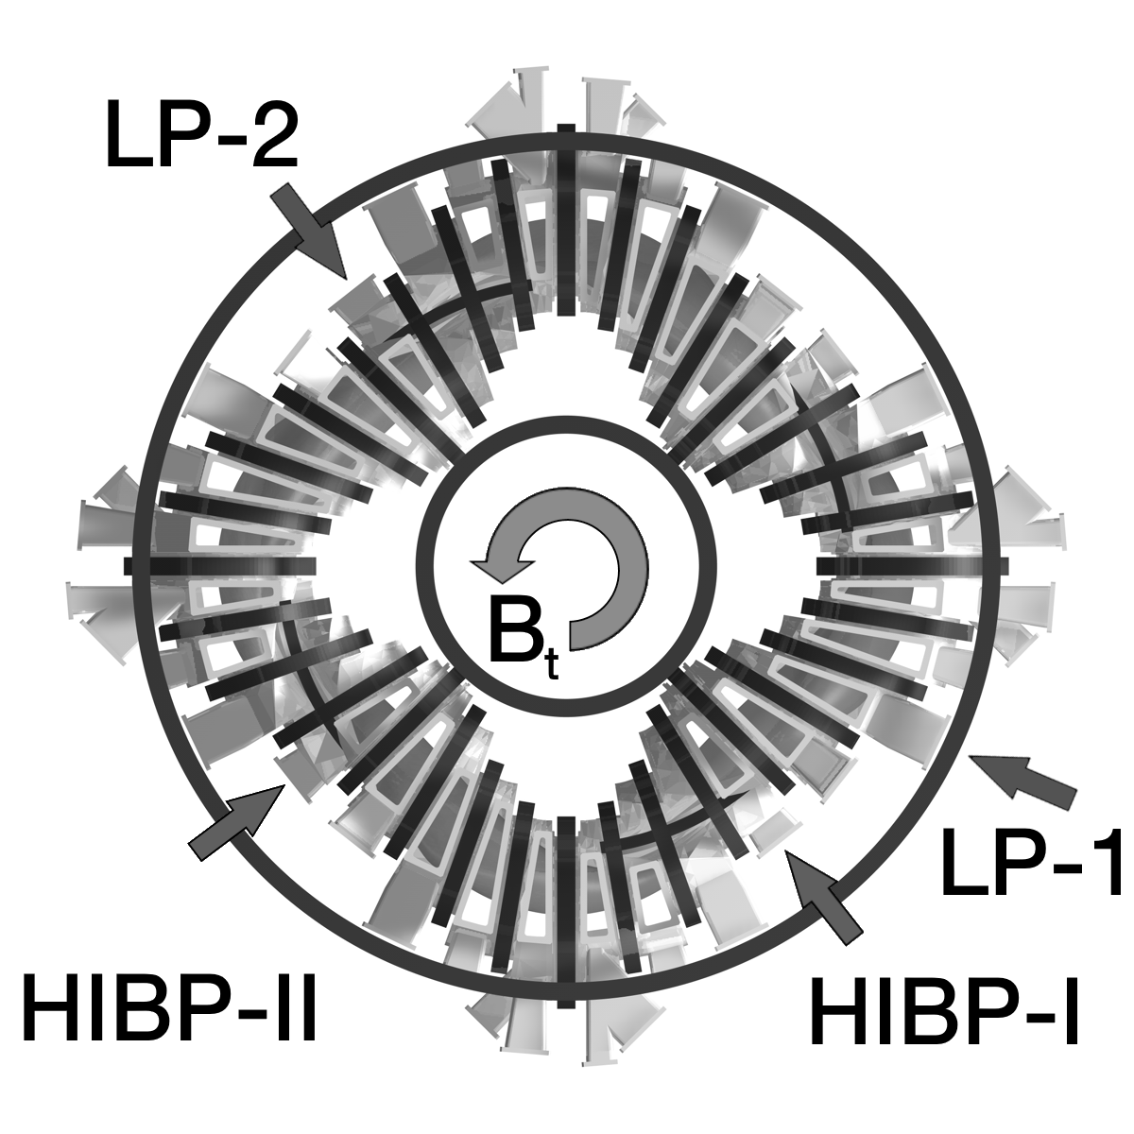
The phenomenon of turbulent particles transport across the confining magnetic field is currently one of the key one in the fusion plasma physics study. The theory predicts [1] that one of the mechanisms for suppressing small-scale turbulence could be zonal flows associated with toroidally and poloidally symmetric (n=m=0) oscillations of the radial electric field. Both low-frequency and high-frequency (GAM - geodesic acoustic mode) zonal flows are studied on many tokamaks and stellarators [2, 3, 4]. The study electric potential fluctuations in the TJ-II stellarator plasmas (Madrid, Spain) is carried out with Heavy Ion Beam Probe double diagnostics and two arrays of Langmuir Probes located in various toroidal cross-sections (see fig. 1).
Fig. 1 Location of HIBP and LP diagnostics on the TJ-II stellarator
In the low-density regime ⟨n_{e}⟩ ≈ 0.5·10¹⁹ m⁻³ and ECR heating P_{ECRH} = 600 kW, two arrays of electric probes showed the radial extension presence of floating potential long-range correlations of the in the 0,85 < ρ < 0,95 diapason [5]. Long-range correlations of the electric potential, detected with double HIBP in a regime with a line-averaged density ⟨n_{e}⟩ ≈ 0.5·10¹⁹ m⁻³ and an input power of P_{ECRH} = 220 kW, were identified as zonal flows [6].
This work is devoted to the cross-correlation analysis of electric potential fluctuations measured by toroidally separated arrays of LP and double HIBP diagnostics in a similar plasma scenario (density ⟨n_{e}⟩ ≈ (0.4÷0.6) 10¹⁹ m⁻³, P_{ECRH} = 460 kW).
References
- P.H. Diamond et al. Zonal flows in plasma—a review // Plasma Phys. Control. Fusion 47 R35 (2005);
- A.V. Melnikov et al. Heavy ion beam probing—diagnostics to study potential and turbulence in toroidal plasmas // Nucl. Fusion 57 072004 (2017);
- Y. Xu et al. Long-distance correlation and zonal flow structures induced by mean E×B shear flows in the biasing H-mode at TEXTOR // Phys. Plasmas 16 110704 (2009);
- A. Fujisawa, A review of zonal flow experiments // Nucl. Fusion 49 013001 (2008);
- U. Losada et al. Spatial characterization of edge zonal flows in the TJ-II stellarator: the roles of plasma heating and isotope mass // Plasma Phys. Control. Fusion 63 044002 (2021);
- G.A. Sarancha et al. Identification of zonal flows and their spatial distribution in the TJ-II stellarator plasmas // JETP Letters 116 2 pp. 98–104 (2022)

*) abstracts of this report in Russian

