Influence of Peripheral Plasma Parameters on the Intensity of Ion Cyclotron Emission in the Ohmic regime IN the TUMAN-3M Tokamak *)
DOI: 10.34854/ICPAF.2023.50.2023.1.1.051
Lebedev S.V., Abdullina G.I., Askinazi L.G., Belokurov A.A., Zhubr N.A., Kornev V.A., Krikunov S.V., Melnik A.D., Razumenko D.V., Smirnov A.I., Tukachinsky A.S., Chernyshev F.V.
Ioffe Institute, Russian Federation, St Petersburg, sergei.lebedev@mail.ioffe.ru
Ion Cyclotron Emission (ICE) in the range of 5-125 MHz was observed in the ohmic regime in the TUMAN-3M tokamak [1,2]. ICE is characterized by frequency dependence on the magnetic probe location ($f∝1/{R_{pr}}$), as well as a large number of equidistant harmonics (up to 15). Observation of the emission in hydrogen and helium discharges and in the absence of auxiliary heating makes it possible to exclude from consideration as possible mechanisms of ICE generation instabilities excited in the presence of energetic particles.
Experiments [1] showed that the ohmic ICE generation region is located on the plasma periphery, and its frequency corresponds to the IC Resonance frequency in the vicinity of the detecting probe. In [1], a possible mechanism of instability responsible for the generation of ICE, i.e., the development of an ion cyclotron drift instability (ICDI) [3], was considered. According to [3], ICDI develops when the following criterion is met:
${ρ_{i}}/{α>2{\left({m_{e}}/{m_{i}}\right)}^{1/2}}$ (1)
where $ρ_{i}$ is the ion Larmor radius, $α=n/{\left({∂n}/{∂r}\right)}$ is the radial scale of the density gradient, $m_{e}$ and $m_{i}$ are the electron and ion masses. The given criterion includes two plasma parameters: the peripheral temperature – $T_{i-edge}$ through the Larmor radius and the relative density gradient at the periphery ${\left.n/{\left({∂n}/{∂r}\right)}\right|}_{edge}$.
The report presents experiments on the perturbation of peripheral plasma parameters in the regime of strong modulation of the working gas (hydrogen) puff rate and an analysis of the effect of this modulation on criterion (1). In experiments, a significant change in the intensity of ICE (~ 8-fold) was found during the modulation of the puff, see Fig.1.
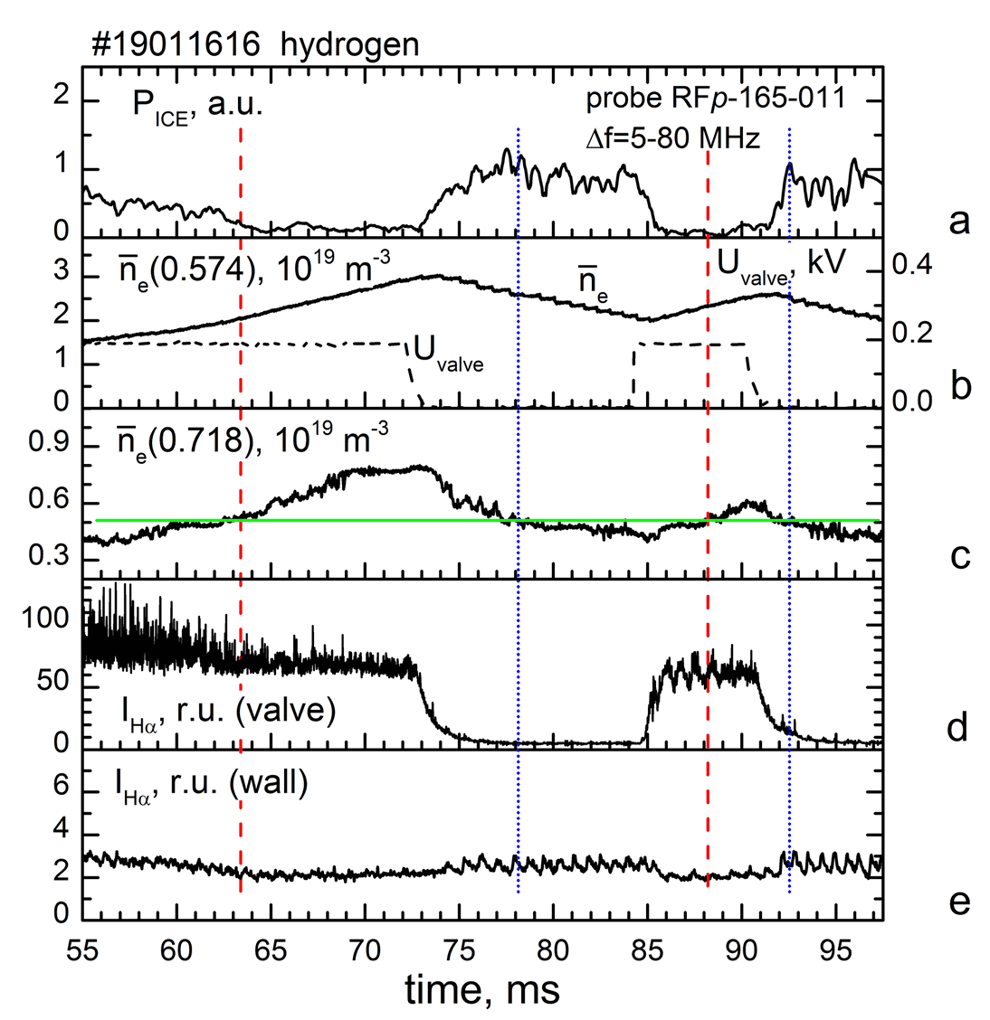

Fig.1. ICE power evolution in the range of 5-80 MHz - frame a,
${\overline{n}}_{e}$ (0.574) and ${\overline{n}}_{e}$ (0.718) - the line average density measured along vertical chords at large radii of 0.574 m (near the magnetic axis) and 0.718 m (the last channel of the microwave interferometer ) are frames b and c, $U_{valve}$ is the voltage applied to the piezoelectric inlet valve - frame b, signals from $H_{α}$ monitors near the hydrogen inlet port - frame d and away from the valve - frame e.
The detecting magnetic probe is located 6.5 cm above the equatorial plane on the side of the weak field.

The analysis showed that the major contribution to the change in criterion (1) in the described experiments is made by the change in the ion temperature, while the contribution from the change in the relative density gradient is negligible.
References
- S.V. Lebedev et al, EPJ Web Conf., 149(2017), 03010
- L.G. Askinazi et al, Nucl. Fusion, 58(2018), 082003
- A.B. Mikhailovsky, Nucl. Fusion, 11(1971), 323

*) abstracts of this report in Russian

