Visualization features of plasma microstructures in the field of laser radiation *)
DOI: 10.34854/ICPAF.2023.50.2023.1.1.168
¹Khirianova A.I., ¹Parkevich E.V., ^{1,2}Smaznova K.T., ^{1,2}Klimovich S.M., ^{1,3}Tolbukhin D.V.
¹P.N. Lebedev Physical Institute of the Russian Academy of Sciences 119991, Moscow,
Russia, khirianova.alexandra@gmail.com,
²Moscow Institute of Physics and Technology 141700, Dolgoprudny, Moscow region, Russia,
³Pskov State University 180000, Pskov, Lenin Square, Russia.
The paper studies in detail the diffraction effects, accompanying the passage of laser radiation through heterogeneous plasma microstructures. Diffraction patterns of plasma objects in their output plane and in the near wave zone are modeled. The data were obtained by solving the scalar wave equation of Helmholtz in the first Rhytov approximation, taking into account the diffraction, blurring of the diffraged laser beam in free space. It was found that even in the simplest approximations of the process of interaction of laser radiation with plasma, the passage of a laser beam through heterogeneous plasma is accompanied by complex diffraction effects. These effects are enhanced in the near-wave zone of the object and significantly distort the obtained pictures of plasma formations, also contributing to the visualization of various optical artifacts in the images. By numerical modeling, it was possible to more accurately characterize the specifics of visualization of real plasma formations in the field of a coherent laser beam registered by the optical system. The results of the work can be widely used in the processing of laser images of plasma microstructures registered in the presence of strong diffraction effects.
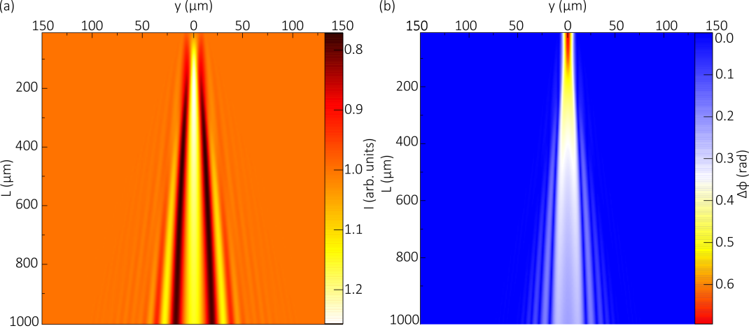
Fig. 1. Two-dimensional maps of the intensity (a) and phase shift (b) of the diffraged wave behind the 20 μm plasma filament. The parameter L (μm) corresponds to the distance from the output plane of the object (x = D).
The work was carried out with the support of the grant of the Russian Science Foundation No. 22-29-00799.
References
- Parkevich E.V., Khirianova A.I. Simulation of Laser Diffraction by Micron-Sized Plasma Filaments. Bulletin of the Lebedev Physics Institute, 49(10), 10-16 (2022), doi: 10.3103/S1068335622100025; https://doi.org/10.3103/S1068335622100025.

*) abstracts of this report in Russian

