UNEXPECTED FEATURES OF SELF-DISCHARGE IGNITION IN CROSSED ELECTRIC AND MAGNETIC FIELDS *)
DOI: 10.34854/ICPAF.2023.50.2023.1.1.135
Strokin N.A., Rigin A.V.
Irkutsk National Research Technical University strokin85@inbox.ru, arseniy.rigin@mail.ru
The understanding that the flow of ions leaving the self-discharge zone in crossed electric and magnetic fields (E×B discharge) can be an indicator of the ignition process – the appearance of electrons and plasma in the anode-cathode gap of an thruster with an anode layer (TAL), led to an experiment to measure the ignition voltage U_{ig} (anode-cathode TAL) and the radial component of the magnetic field induction at the TAL cathode B_{rKig} in the moment of the signal appearance on the ion collector. An additional advantage of “ion tracking” was the ability to explicitly show that the self-sustaining discharge does extend to the entire anode-cathode gap, since ions with energies of 50 eV ≤ W_{i} ≤ eU_{A} come to the ion collector, which was an element of the energy analyzer with a retarding potential (RFA) at the time of ignition (U_{A} is the potential of the anode). As a result, 2 stationary modes of the E×B discharge were detected, starting each of them with the ignition moments – a sharp increase in the discharge current from 0 (neutral gas) to I₁ (point B in Fig. 1a) and from I₁ (stationary mode of abnormal glow discharge) to I₂ (point D in Fig. 1a). Two current jumps “in the glow discharge mode” and in the glow discharge mode are the fundamental difference between a E×B discharge and a discharge without a magnetic field. You can build the following line of generation of E×B discharge: mode I of the anomalous glow discharge – mode II of the anomalous glow discharge – arc discharge.
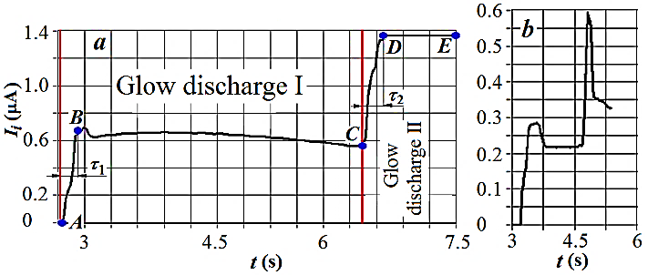
Fig. 1. Ignition curve E×B discharge: dU_{RFA}/dt = (2 V)/(30 mс); a) neon; gas inlet rate q_{Ne} = 80 sccm, U_{ig} = 1150 V, В_{rKig.I} = 1477 G, В_{rKig.II} = 2145 G; b) argon, 5 sccm, U_{ig} = 1044 V, В_{rKig.I} = 1427 G, В_{rKig.II} = 1625 G.
Working on mixtures of inert gases, it was impossible to ignore experiments with “Penning pairs” – in our case, mixtures of neon with argon or krypton, in which the excitation potential of neon into a metastable state is about 16.7 eV, which exceeds the ionization potentials of argon (15.7 eV) and krypton (14 eV). The natural, “according to Penning”, behavior of the ignition curve B_{ig(rK)} = f(q) – reduction of the energy input from the electromagnetic field required for the ignition of the discharge – was observed when argon or krypton was added to neon as an impurity. However, if neon was an additive to argon or krypton, the ignition induction increased to q_{Ne} ≈ 30 sccm and then monotonically decreased, not reaching the starting value at q_{Ne} ≤ 90 sccm; the Penning effect (explicitly) did not work here. The difference in the behavior of Penning pairs when their role in the pair changes – the main gas or impurity – we explain the varying degree of influence of the discharge on the distribution of potential in the cathode region.

*) abstracts of this report in Russian

