Threshold effects of generating strongly ionized plasma in pulsed nanosecond air discharge *)
DOI: 10.34854/ICPAF.2023.50.2023.1.1.169
¹Parkevich E.V., 1Khirianova A.I., ^{1,2}Smaznova K.T., ^{1,2}Klimovich S.M., ^{1,3}Tolbukhin D.V.
¹P.N. Lebedev Physical Institute of the Russian Academy of Sciences 119991, Moscow,
Russia, parkevich@phystech.edu,
²Moscow Institute of Physics and Technology 141700, Dolgoprudny, Moscow region, Russia,
³Pskov State University 180000, Pskov, Lenin Square, Russia.
The work studies the effect of the limiting current through the discharge interval on the dynamics of the formation of a strongly ionized electrode plasma during the development of a pulsed nanosecond discharge in the air. The experiments were carried out on a high-voltage stand with varying current through a discharge interval from several tens to several hundred amperes. The dynamics and parameters of the discharge plasma were studied using laser probing techniques. As a result, it was found that the limitation of the current through a gap of up to several tens of amperes leads to a sharp drop in the rate of plasma development from the cathode, as well as to a decrease in the magnitude of its electron density (Fig. 1). The early stage of plasma development, associated with the formation of a micron cathode spot, turns out to be identical at currents with an amplitude of ~10 to ~100 A. It was found that at currents of several tens of amperes, the development of a microstructure at the spark channel growing from the cathode is not observed.
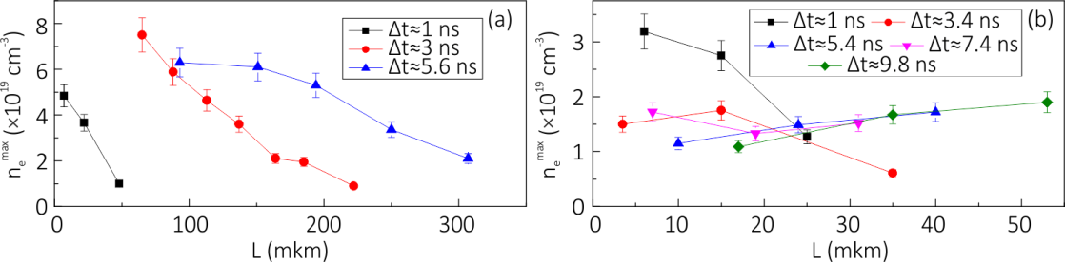
Fig. 1. Distribution of the electron density of plasma along the plasma channel from the cathode: (a) - at discharge current I_{max} ~ 300 A, (b) - at discharge current I_{max} ~ 40 A. The parameter L (μm) corresponds to the distance from the surface of the cathode to the point of determination of the electron density of the plasma in the center of symmetry of the growing spark channel.
The work was carried out with the support of the grant of the Russian Science Foundation No. 22-29-00799.
References
- Parkevich E.V., Khirianova A.I. On the Possible Threshold Character of the Spark Microstructure Formation. Bulletin of the Lebedev Physics Institute, 49(9), 302-306 (2022), doi: 10.3103/S1068335622090068; https://doi.org/10.3103/S1068335622090068.

*) abstracts of this report in Russian

