Investigation of a RF-discharge by Langmuir Probe Diagnostics and Optical Emission Spectrometry (OES) *)
DOI: 10.34854/ICPAF.2023.50.2023.1.1.155
¹Tran Q.V., ^{1,2}Budaev V.P., ^{1,}3Kavyrshin D.I., ¹Fedorovich S.D., ^{1,2}Karpov A.V., ¹Rogozin K.A., ¹Konkov A.A.
¹National Research University “MPEI”, Moscow, Russia
²National Research Center "Kurchatov Institute", Moscow, Russia
³Joint Institute for High Temperatures of the Russian Academy of Sciences (JIHT RAS),
Moscow, Russia
The helicon-type RF-discharge is widely used for the development of a space plasma engine, testing of materials for thermonuclear installations, in mechanical engineering, medicine, due to its greater efficiency. We note the technical simplicity of this plasma source; for their operation, RF generators at industrial frequency (13.56 MHz and 27.12 MHz) are used, operating on simple antennas in the presence of a weak magnetic field (from 0.01 to 0.2 T) , low operating pressure 0.1 to 50 Pa, the plasma has an electron temperature about 10 eV and a electron density up to 10²⁰ m^{–3}.
In this work, using an RF-compensated Langmuir probe, the electron energy distribution function (EEDF) is constructed, the electron density and electron temperature are determined as a function of pressure [1]. The measurements were carried out in the pressure range of 10–500 mTorr. On fig. 1 shows a schematic diagram of the experimental stand. Energy with a power of 2 kW from the RF generator is transferred to the antenna through a matching system. The magnetic field has values ​​from 1 mT to 72 mT, which will satisfy the condition for excitation of electromagnetic helicon waves at a frequency of 27.12 MHz. Working gas: argon and helium. A cooled antenna has been developed that will allow a stationary mode of operation.
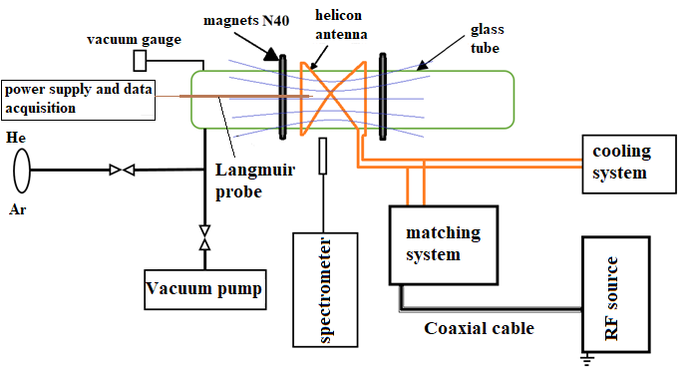
Fig. 1. Schematic diagram of the experimental stand
Optical spectroscopic measurements of the intensity of the spectral lines of the atomic and ion plasma-forming gas have been carried out. The density and temperature of electrons are estimated using the collisional-radiative model for describing the state of plasma [2].
The spectroscopic study was supported by the RSF grant 21-79-10281.
References
- M.A. Lieberman and A.J. Lichtenberg, Principles of Plasma Discharges and Materials Processing (John Wiley & Sons, New York, 1994).
- F.F. Chen, “Electric probes,” in Plasma Diagnostic Techniques, edited by R.H. Huddlestone and S.L. Leonard (Academic Press, New York, 1965).

*) abstracts of this report in Russian

