FORMATION OF A CURRENT SHEATH AND ITS CONFIGURATION DURING THE OPERATION OF A PLASMA FOCUS ON DEUTERIUM AND WITH SUBSTITUTING ADDITIVES OF INERT GASES *)
DOI: 10.34854/ICPAF.2023.50.2023.1.1.125
¹Lototsky A.P., ¹Grabovsky E.V., ¹Efremov N.M., ¹Krylov M.K., ¹Panfilov D.G., ¹Seryakov A.G., ¹Nikolashin A.A., ¹Lauhin Ya.N., ²Lukin V.V.
¹SSC RF TRINITI, lototsky@triniti.ru,
²IPM im. M.V. Keldysh,
To solve the main task set - the development of a PF installation with discharge currents of more than 2-3 MA, a scheme with a heavy current plasma sheath (HPC) compressing the injected deuterium jet was previously considered. Its fundamental performance is shown in [1, 2] on a mock-up (600 kA) with an initial helium SST. In these experiments, features of the formation of PCS appeared, some of which, such as an increase in the uniformity of the axial current distribution, are known [3], while others (delay in the development of the discharge) had to be dealt with in various ways. The performed processing of magnetic probe measurements shows a significant change in the shape of PCS during its acceleration in the interelectrode gap [1]. A change in the configuration can significantly affect the dynamics of the final cumulation process, the size of the pinch formation, and the efficiency of deuterium jet compression. Experiments were carried out during the operation of the PF with a change in the mass addition of inert gases argon and xenon to deuterium with registration of the neutron yield.
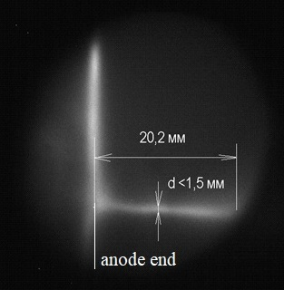
Based on the movement of the secondary current sheath, which is formed during breakdown through the insulator at the moment of the current singularity, the density of the residual gas behind the PCS front and the transparency of the PCS itself are estimated, which is important for efficient compression of deuterium. A number of surveys (see figure) of a pinch discharge were carried out using a high-speed image intensifier tube (50 ns), and spectrograms were obtained showing the absorption of the pinch plasma continuum in the spectral lines of the TPO gas of the compressing shell. An approach is developed to the numerical simulation of the problem of the passage of a current front through the interface between two gases at the stage of pinch cumulation.

References
- VANT, 2022, volume 45, p. 119-144.
- Plasma Physics, 2022, volume 48, no. 11, pp. 1-5.
- V.V. Vikhrev, S.I. Braginsky. Questions of Plasma Theory, M., Atomizdat, 1980, volume 10, p. 243-312.

*) abstracts of this report in Russian

