REGULARITIES IN multicharged ION IONIZATION POTENTIAL DEPENDENCE ON NUMBER OF ELECTRONS N AND ATOMIC NUMBER Z *)
DOI: 10.34854/ICPAF.2023.50.2023.1.1.122
Shpatakovskaya G.V.
KIAM RAS, Moscow, Russia, shpagalya@yandex.ru
The analysis of experimental and calculated ionization potentials $I_{N}^{(Z)}$(eV) is carried out in the ground state of multicharged ions of medium and heavy elements from argon (Z = 18) to americium (Z = 95), presented in the NIST tables [1]. These data, considered in special coordinates, indicate patterns in the dependence on the atomic number of the element Z and number of electrons in the ion N. The discovered patterns allow us to approximate a large number of tabular values by simple polynomials of the form:
$$I_{N}^{(Z)}=Z^{4/3}{10}^{\lg{e_{N}(σ)}}E_{H}, \lg{e_{N}\left(σ\right)= \sum_{i=0}^{i_{max}}{\sum_{k=0}^{k_{max}}{b_{ik}N^{k}σ^{i}}}}, σ=πZ^{-1/3}, { E}_{H}=27.211 eV.$$
The optimal division is into a group of medium elements, from argon to xenon (18 ≤ Z ≤ 54) with the number of electrons in the range N ≤ Z $-$ 5 [2], and a group of heavy elements, from caesium to americium (55 ≤ Z ≤ 95) with the number of electrons 1 ≤ N ≤ 46 [3]. In this case, the degree of approximating polynomials does not exceed three, and small tables of polynomial coefficients $b_{ik}$ make it possible to estimate the ionization potentials with an accuracy of about 1 percent or higher for a total of about three thousand ions from the considered regions. The figures show the characteristic dependences of the ionization potentials of a group of medium elements from K and L shells (Fig.1) and heavy elements from the M shell (Fig.2).
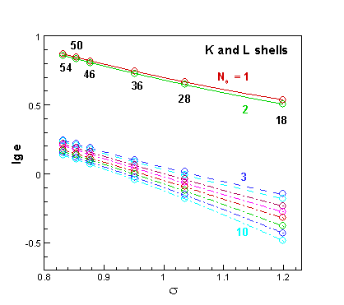 | 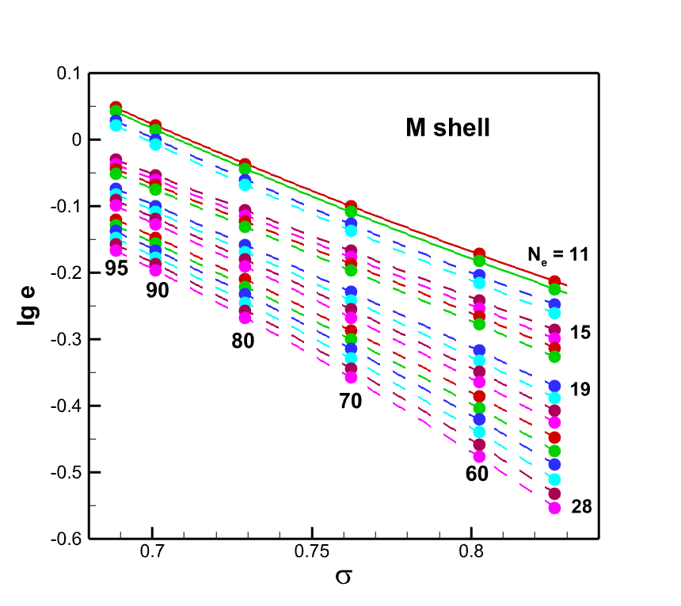
Fig.1 | Fig.2
References
- Kramida A., Ralchenko Yu., Reader J. and NIST ASD Team (2022). NIST Atomic Spectra Database (ver. 5.10). [Online] Available: https://physics.nist.gov/asd [2022, November 2]
- Shpatakovskaya G.V. JETP, 2022, 135, 179-187
- Shpatakovskaya G.V. JETP Letters, 2021, 114, 737-741

*) abstracts of this report in Russian

