RECONSTRUCTION OF LASER PLASMA IMAGE IN SOFT X-RAY spectral RANGE by the use of CODed APERTURE *)
DOI: 10.34854/ICPAF.2023.50.2023.1.1.108
¹Kologrivov A.A., ¹Rupasov A.A., ¹Bolkhovitinov E.A., ³Ivanov O.P., ³Potapov V.N., ²Stuchebryukhov I.A., ²Abrosimov S.A.
¹Lebedev Physical Institute of RAS, Moscow, Russia.
²Prokhorov General Physics Institute of RAS, Moscow, Russia.
³National Research Center "Kurchatov Institute", Moscow, Russia.
Important information about the processes occurring in high-temperature plasma (for example, laser-produced plasma, high-voltage vacuum discharge, exploding wires, etc.) is provided by the study of X-ray radiation with spatial resolution. For this purpose, in experimental practice, a pinhole camera is widely used, which is a small-diameter hole in a screen opaque to X-rays. The most important advantage of the pinhole camera is the ease of manufacture and application. However, due to the low aperture of the pinhole camera, the energy of radiation that comes to the detector is often insufficient to obtain a high-quality image. This forces one to find other instruments to obtain an image of the plasma object under study. One of such instruments is the coded aperture (CA), which is a structure of intersecting mutually perpendicular transparent and opaque stripes. Such CA (Fig. 1a) was used in joint experiments of LPI of RAS and GPI of RAS on the study of laser plasma images in the X-ray range at the Kamerton-T facility. CA with a size of 1x1 mm was used, which, according to the structure and correlation properties, is close to a PnP-type CA [1]. The encoded image was recorded on Fuji TR fluorescent imaging plate without a protective coating.
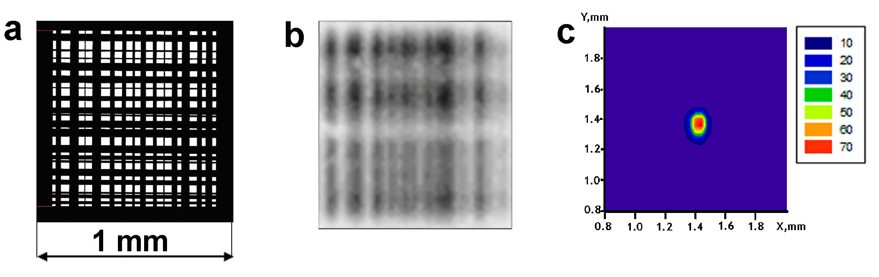
Fig.1. a) - view of the coded aperture; b) – encoded pattern formed on the detector; c) – plasma image reconstructed from the encoded pattern.
The radiation transmitted through the CA gives a complicated pattern of the encoded image (Fig.1b), therefore, the use of a mathematical procedure for reconstructing the real plasma image is required. This procedure was developed at the Kurchatov Institute and it is an iteration method for solving an incorrectly posed problem – Fredholm integral equation of the 1-st kind. The result of this procedure is presented in Fig.1c. It was shown that the use of a coded aperture not only increases the light efficiency of the recording system many times, but also allows one to obtain a spatial resolution no worse than in the case of a pinhole camera. For laser-produced plasma, the application of CA as an element of image reconstruction was performed for the first time.
References
- Gottesman S.R., Schneider E.J., PnP - A new class of encoded aperture matrices, IEEE Transactions on Nuclear Science, 1986, v. 33, No. 1, p. 745.

*) abstracts of this report in Russian

