SMALL-SIZED CURRENT pulse GENERATORS FOR X-PINCHES *)
DOI: 10.34854/ICPAF.2023.50.2023.1.1.116
Pikuz S.A., Shelkovenko T.A.
P.N. Lebedev Physical Institute, Moscow, Russia, pikuz@mail.ru
For the successful operation of the X-pinch as an ultra–bright source of soft X-ray radiation (SXR, range 0.5 - 10 keV), it is necessary to fulfill the Shelkovenko condition for the rate of current rise in the load
dI/dt > 1 kA/ns, (1)
The minimum value of the current amplitude when the formation of a hot spot with extreme plasma parameters was observed was approximately 50 kA. As recent studies have shown, a lower rate of current rise may be sufficient to generate harsher radiation (HXR, E > 10 keV). However, at the same time, the generation mechanism is different, associated with the breakage of the current conductivity of the underloaded X-pinch and the quality of radiation is not as high as the quality of soft radiation of the hotspot.
There are two concepts for ensuring the fulfillment of condition (1): a) – the use of high–voltage capacitor banks with extremely low intrinsic inductance and special switches, and b) – the use of storage devices with spreaded parameters (forming lines) - see Figure.

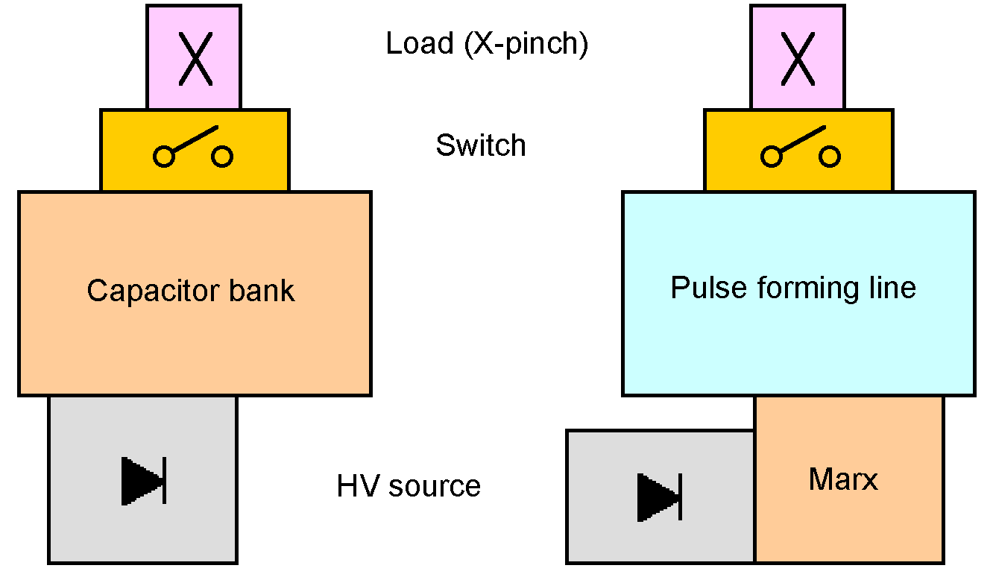

An example of a generator with a capacitor bank is the KING installation operating in Lebedev Institute, designed and manufactured in IHCE SDAS. Experiments have shown that X-pinch on generators of this type, with proper load selection, is a fairly effective source of SXR. However, criterion (1) is performed at the limit of technical capabilities and the selection of loads is very limited. An increase in the rate of current rise in capacitor systems is possible with an increase in the operating voltage, which is associated with great technical difficulties. An increase in the operating voltage is easily achieved in circuits with water coaxial forming lines. Despite the fact that the energy reserve of the forming line at an equal size is less than that of the capacitor bank, the fulfillment of criterion (1) is easily ensured. Modern water treatment systems make it possible to obtain deionized water with a resistivity of up to 10 mOhm.cm. At the same time, there is no need to use an intermediate storage device for charging the forming line and create small-sized installations.
This work was supported by the Russian Science Foundation (project no. 19-79-30086).

*) abstracts of this report in Russian

