the Theory of mse diagnostics in the parabolic coordiantes *)
DOI: 10.34854/ICPAF.2023.50.2023.1.1.239
¹Demura A.V., ¹Leontyev D.S., ²Letunov A.Y., ¹Lisitsa V.S.
¹NRC “Kurchatov Institute”, Moscow, Russia
²RFNC-VNIITF, Snezhinsk, Russia
MSE diagnostics is one of the bases for determining the current and magnetic structure in modern tokamaks. It is based on measurements of the Stark structure of a hydrogen beam during its passing through the magnetic field of the facility [1, 2].
When a neutral hydrogen beam passes through a plasma, an induced electric field E arises in its coordinate system, leading to a splitting of the energy levels of the atom with a formation of a polarized Stark spectrum consisting of two components: the π-component with polarization vector parallel E and the σ-component, with the polarization vector lying in the perpendicular to E plane (Motional Stark Effect – MSE) [2].
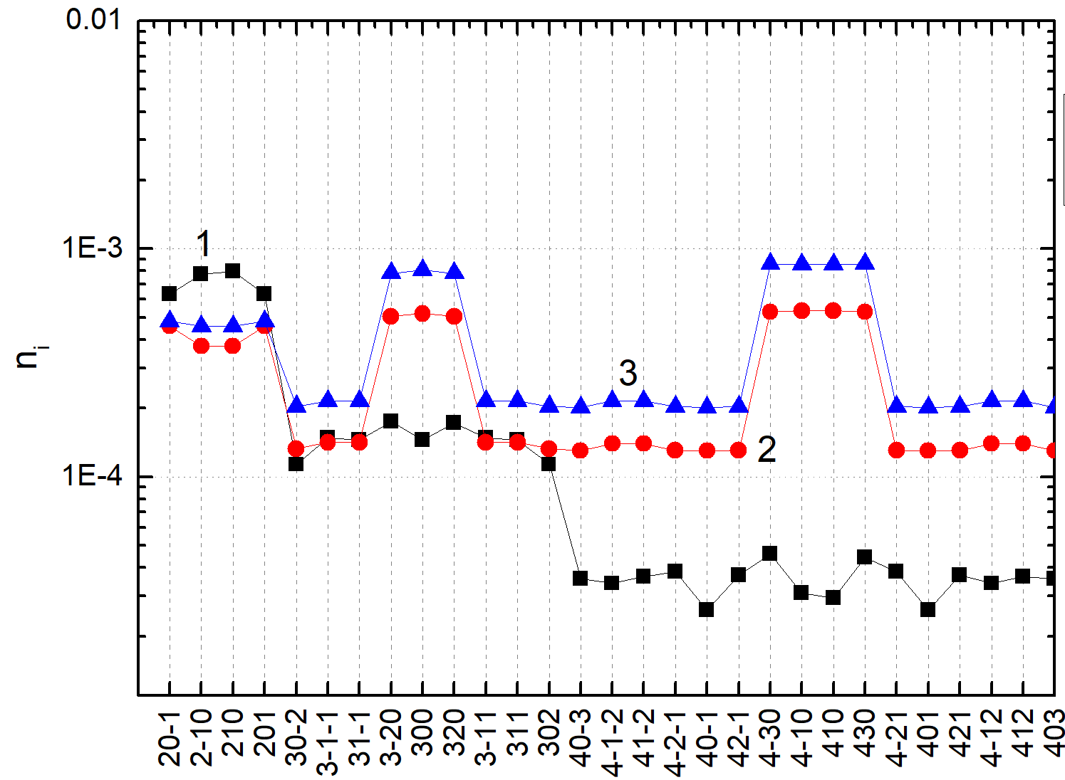
In this work, the cross-sections of the excitation transitions in a hydrogen atom upon collision with protons were calculated in the approximation of sudden perturbation using parabolic wave functions. The calculations of the spectra in the laboratory observation system related to the wave functions with quantization axis along the electric field were carried out using the expansion in terms of the basis of the parabolic wave functions oriented along the momentum transfer vector q, which simplified the computations of the matrix elements. To calculate the transition excitation probability, normalization conditions [3, 4] were used, which make it possible to eliminate the discrepancy of the transition cross sections. The radiative decay rates were estimated by Gordon formulas [5]. On the basis of data of the radiative-collisional processes, a kinetic model was constructed to determine the populations of the first four levels of the hydrogen atom. At the same time, two cases were considered: 1) from the level n=4 radiative decay occurs to lower levels; 2) from the 4th level the ionization of the atom occurs and there is no radiative decay. Figure 1 shows the levels population estimated in the work. Comparison with the data of [6] revealed a fairly good agreement between the data for the populations of the levels with n=2 and n=3.
Fig. 1 Relative populations of hydrogen levels for beam energy E=50 keV, proton concentration Np=3‧10¹³ cm⁻³ of magnetic field B=1.5 T. 1) data from [6]; 2) calculation with radiation from level 4 (1); 3) calculation without radiation from level 4 (2).
References
- Крупин В.А. и др. РАЗРАБОТКА MSE ДИАГНОСТИКИ ПРОФИЛЯ ТОКА ДЛЯ УСТАНОВКИ Т-10. Москва: РНЦ “Курчатовский институт,” 1995. 33 с.
- Marchuk O. et al. Collisional excitation and emission of Hα Stark multiplet in fusion plasmas // J. Phys. B At. Mol. Opt. Phys. 2009. Vol. 43, № 1.
- Skobelev I.Y., Vinogradov A. V. Coulomb-Born and unitarised Coulomb-Born cross sections and rates of inelastic transitions in ion-ion collisions // J. Phys. B At. Mol. Phys. 1978. Vol. 11, № 16. P. 2899–2905.
- Виноградов А.В. и др. Сечения и скорости неупругих переходов между близкими уровнями // Успехи Физических Наук. 1980. Т. 119. С. 120–129.
- Bethe H.A., Salpiter E.E. Quantum mechanics of one- and two-electron atoms. Berlin: Springer-Verlag, 1957. 375 p.
- Ralchenko Y. et al. A non-statistical atomic model for beam emission and motional Stark effect diagnostics in fusion plasmas // Rev. Sci. Instrum. 2012. Vol. 83, № 10. P. 1–4.

*) abstracts of this report in Russian

