INNOVATIONS AND ACHIEVEMENTS OF THE HYBRID SWITCH OF THE ITER SWITCHING NETWORK UNIT (SNU) *)
DOI: 10.34854/ICPAF.2023.50.2023.1.1.221
Alekseev D.I., Karpishin M.V., Manzuk M.V., Roshal A.G., Semenov A.I., Solenyi A.A.
JSC “NIIEFA” – Saint-Petersburg, Russia, dmitry.alekseev@sintez.niiefa.spb.su
The International Experimental Thermonuclear Reactor ITER is a unique electrophysical facility capable of reproducing a controlled thermonuclear reaction occurring in the bowels of stars in terrestrial conditions.
A durational (about 20 minutes) combustion mode of plasma discharge combining with the huge power capacity of the superconducting coils of the ITER tokamak requires, on the one hand, a high capacity of power supply to quickly raise the current in the initial part of the pulse, and on the other hand, the power supply must be designed to maintain current for a long time during the flat top, which is virtually unattainable in traditional power supplies.
This circumstance predetermined the use of the superconducting coils as an inductive storage device in order to create the conditions necessary for the Joule heating and breakdown of the plasma cord. In this case, before the beginning of the operating pulse, a countercurrent with respect to the current during the flat top is started in the coil, and then an active resistance is introduced into the current loop - in the process of energy release on it, stored in the coil magnetic field, an eddy electric field, necessary to initiate current in plasma, is created.
As a result, it became necessary to create a switching complex to perform operational switching in DC circuits, the value of which reaches 45 kiloamperes. Commutation of direct currents of such magnitude in circuits with high inductance is a complex engineering and scientific and technical problem, which cannot be solved using standard industrial electrical equipment.
The function of DC interruption at plasma discharge initiation is assigned to multistage hybrid switches, which are parts of the switching network unit, the electric diagram of which is shown in figure 1.
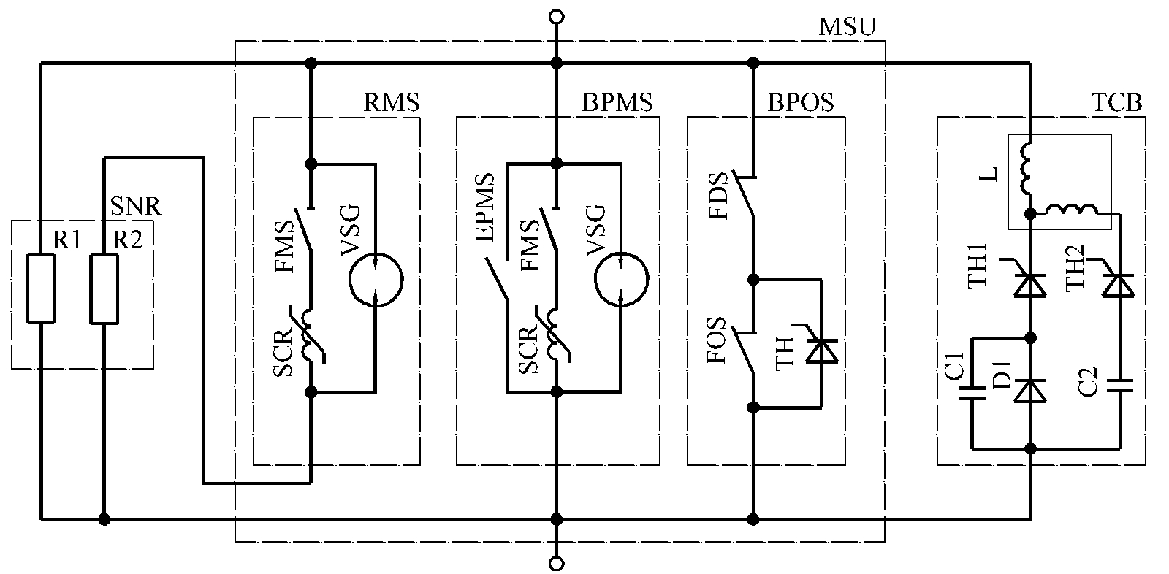
Fig. 1.
The basis of the hybrid circuit breaker is pneumodynamically driven devices, which are designed for long-term flow of high direct currents, and provide arcless current commutation in the energy-absorbing resistor circuit by means of a two-stage countercurrent system.
SNU was developed and tested in JSC “NIIEFA” as part of the work according to the Procurement Arrangement 4.1.P3.RF.01.

*) abstracts of this report in Russian

